**NORTHEASTERN UNIVERSITY**

**INFORMATION SYSTEMS SPRING ’21**



***Parallel Deep Learning Neural Networks and GAN to detect features on CelebFaces Dataset***

**Parallel Machine Learning & AI**

CSYE7105–37380

**Guided By:**

**Prof. Handan Liu**

**Created By:**

**Team- 5**

**Hemant Jain**

# **ACKNOWLEDGEMENT**

It gives me a great pleasure and immense satisfaction in presenting the project “***Parallel Deep Learning Neural Networks and GAN to detect features on CelebFaces Dataset***” in regard to Parallel Machine Learning and AI coursework at Northeastern University in Spring 2021.

I would like to take this opportunity to acknowledge the innumerable guidance and support extended to me by our **Professor Handan Liu** in the execution and preparation of the project.

I would like to thank our **TA Mr. Chaoyi Yuan** who has helped me with his valuable suggestions and guidance. Finally, I am intended to our very own Northeastern University for giving us the platform to express and exhibit our talent.

I would also like to thank Professor for giving me an opportunity this semester to attend the Nvidia GTC 2021 - GPU Technology Conference and listening and seeing the active contributions in the GPU world and high parallel processing computing technology.

Any bouquets for the merit of this project should go to above mentioned persons

**Introduction**

**I. Background**

The 2 methodologies I came across and decided to move forward with for our analysis are

the following:

* Convolutional Neural Network(CNN): It is a type of neural network that allows for extraction of higher representation of image content. CNN takes images in raw pixel data, trains the model , then extracts the features from it and gives a better classification output

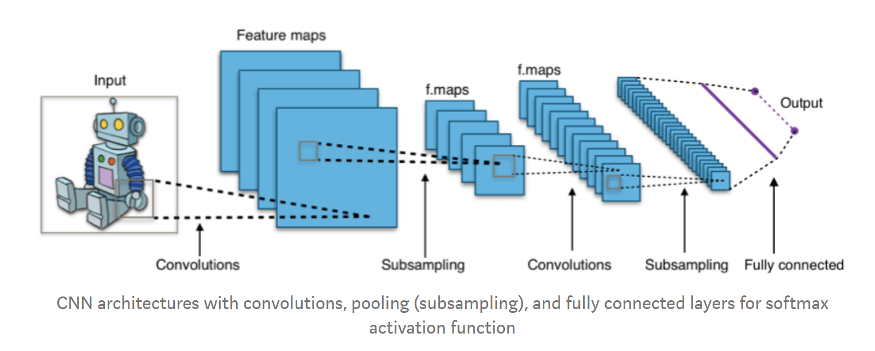

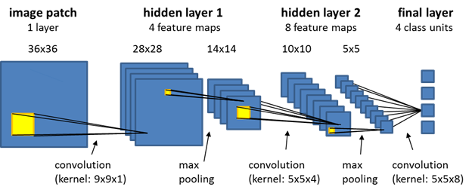

* Generative adversarial network(GAN): which is about creating images; like drawing a portrait. The main focus of GAN’s is to generate data from scratch, which are mostly images. It is a neural network architecture with a game theoretic approach, the 2 model components are generator and discriminator. The role of the generator is to fool the discriminator with fake images and the discriminator learn how not to get fooled and identify the fake images

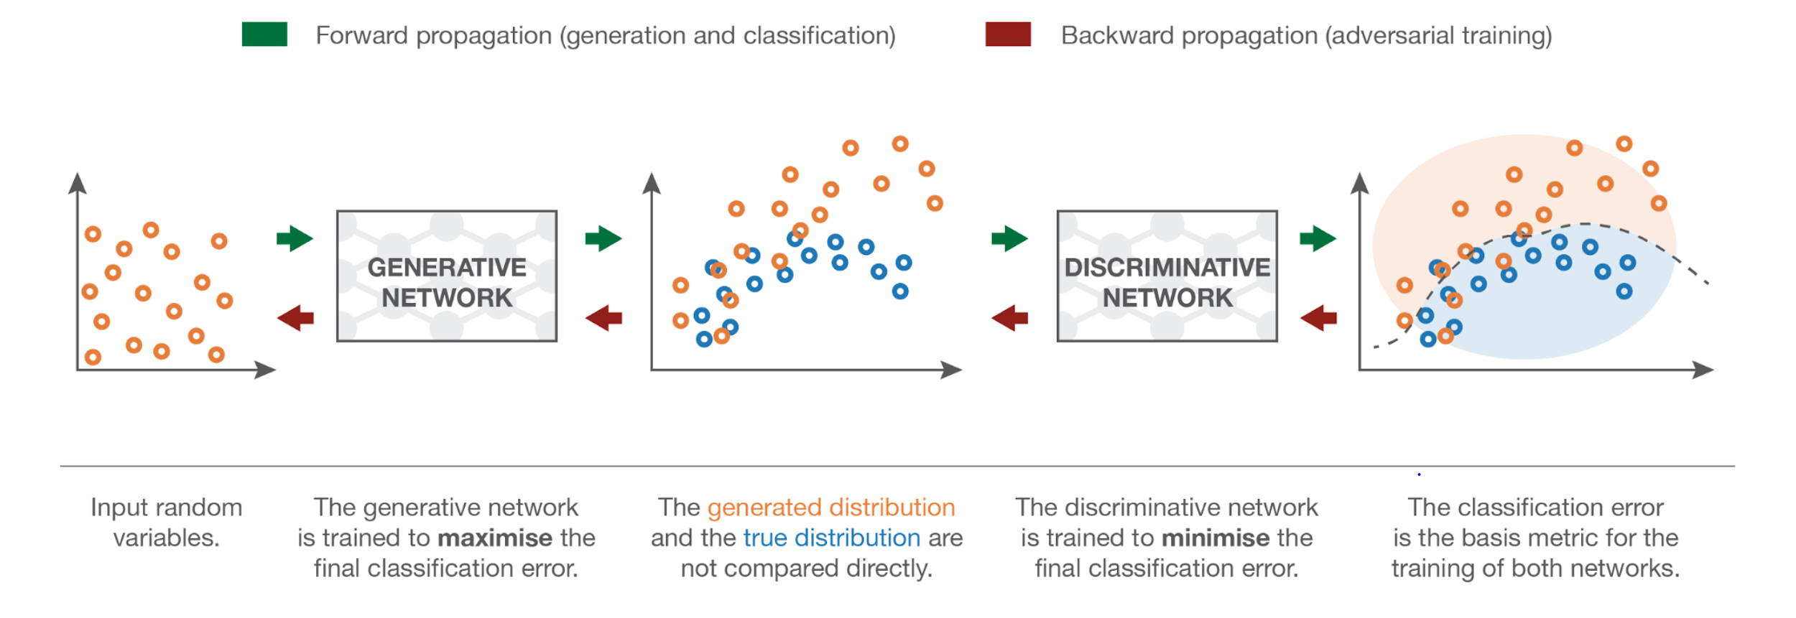

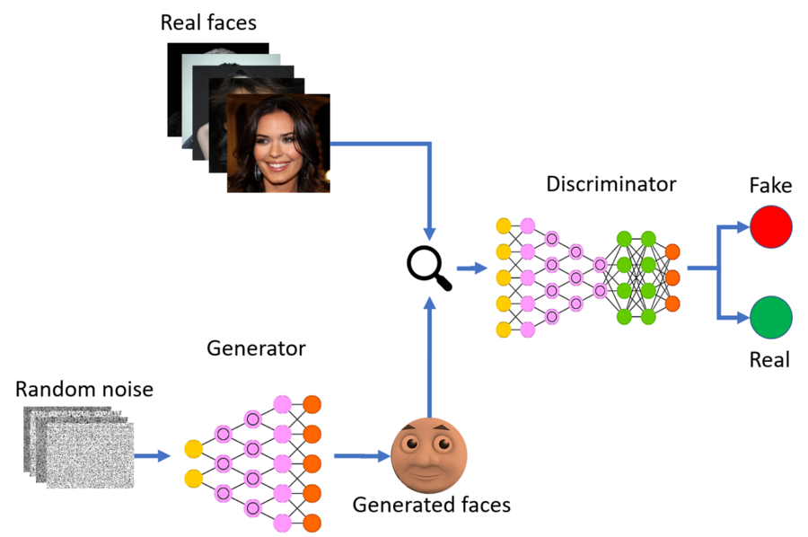

**II. Motivation**

In recent years, the amount of data being used and created by companies and people has grown exponentially. This has led many avenues to come out to the forefront that make use of data to construct models and systems to further optimize a company’s services and provide a better consumer experience.

Deep learning is a popular tool that has grown tremendously and has applications in many real-life scenarios. These models are used to create artificial intelligence in a system to perform a certain human task and learn through past data. In our project I focused on using two such methods: Convolutional Neural Networks, and Generative Adversarial Networks.

Convolutional Neural Networks is one such deep learning tool which is primarily used on image data and consists of having layers upon layers of nodes with multiple channels and a convolution mask to analyze the pixel values of each image and to learn and accordingly adjust the weights of the model.

GAN’s is an unsupervised method of learning and is primarily used for data generation. Our project group decided to work with GAN’s to get a better understanding of how to create such a network.

**III. Goals:**

The goal of this project is to make predictions on the celebrity face dataset using deep learning algorithms. I was set to predict the hair features for the celebrities and guess their gender using Convolutional Neural Network (CNN). I also decided to generate fake faces using Generative adversarial network (GAN) and building and deploying the machine learning model in the streamlit based web application where you can generate fake faces in real-time.

**Methodology:**

With the goal set for the project to make predictions for the celebrity images dataset. I decided to move forward with 2 methods

1. Convolutional Neural Network (CNN)
2. Generative adversarial network (GAN)
3. Streamlit based web app for fake celebrity face generation

Using Pytorch and parallelizing it using cuda on multiple GPU’s

**Step 1: Gender Prediction with CNN on Pytorch**

* Exploratory Data Analysis:

1. The attribute csv file had the column values of -1 and 1 which I change to 0

and 1 for better prediction

1. The partition csv file had all the training, validation, and test data in one with values 0,1 and 2 for identification which I split into 3 different files.

* With using a custom dataset in Pytorch I had to construct our own class for loading this dataset.

This required three functions:

1. __init__: Used to initialize the csv, the image directory, and the transforms
2. __len__: Returns the length of the images within the csv
3. __getitem__: Joins the paths images with their respective labels and returns the values

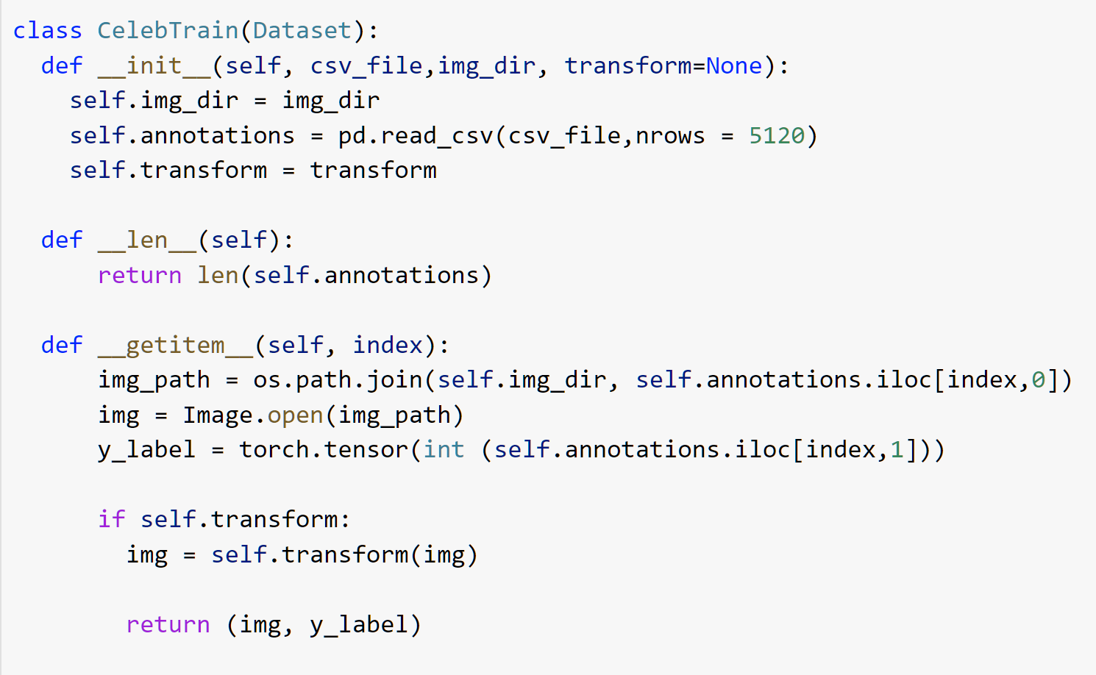

* With CNN I performed image classification of the celebrity images predicting the gender they belong to using the gender column in the attribute csv file of our dataset.

Below is the code snippet of the CNN model for gender prediction

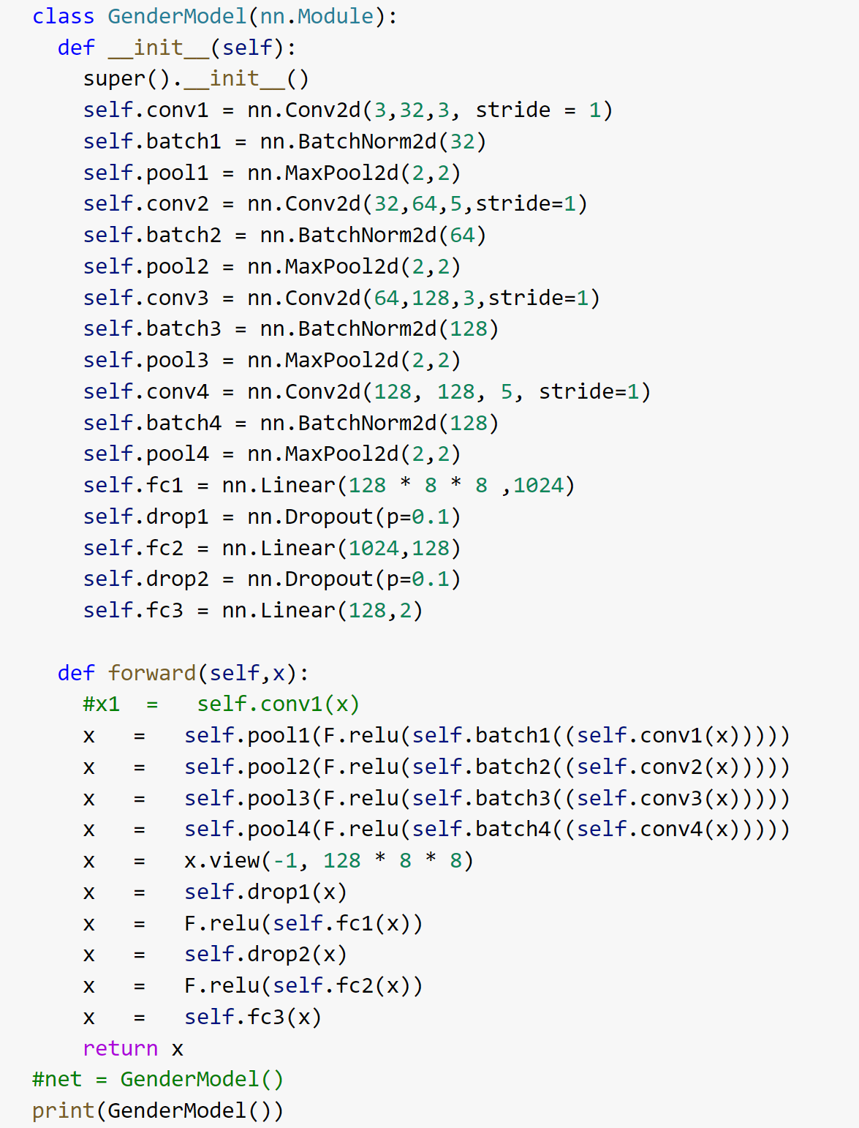

* Designed the CNN model for gender prediction with 4 layers which was able to learn on the training dataset and predict the correct gender when tested on the test dataset with an accuracy of 94%

The model was trained using a train function

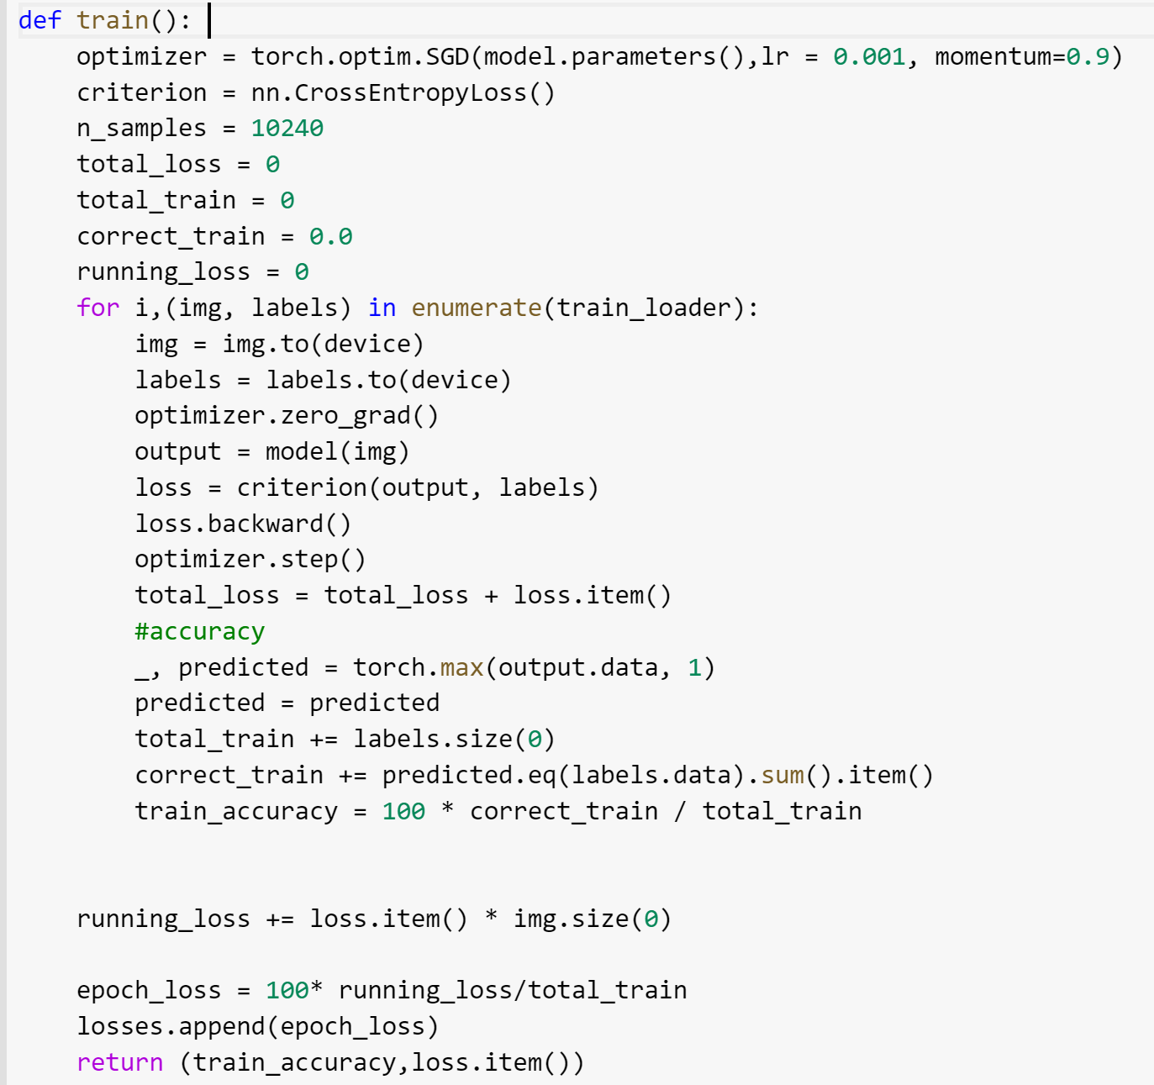

The model was validated running the epochs on the validation dataset

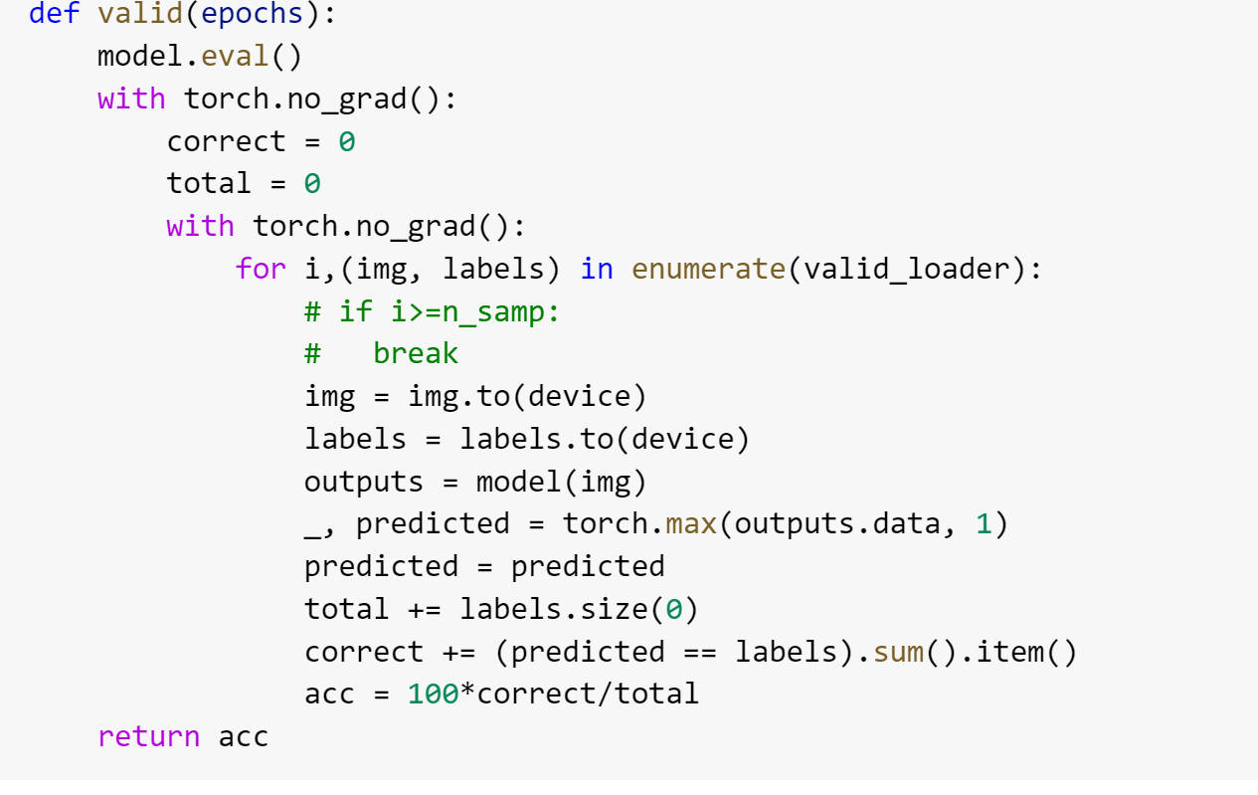

Tested the model through a Predict function

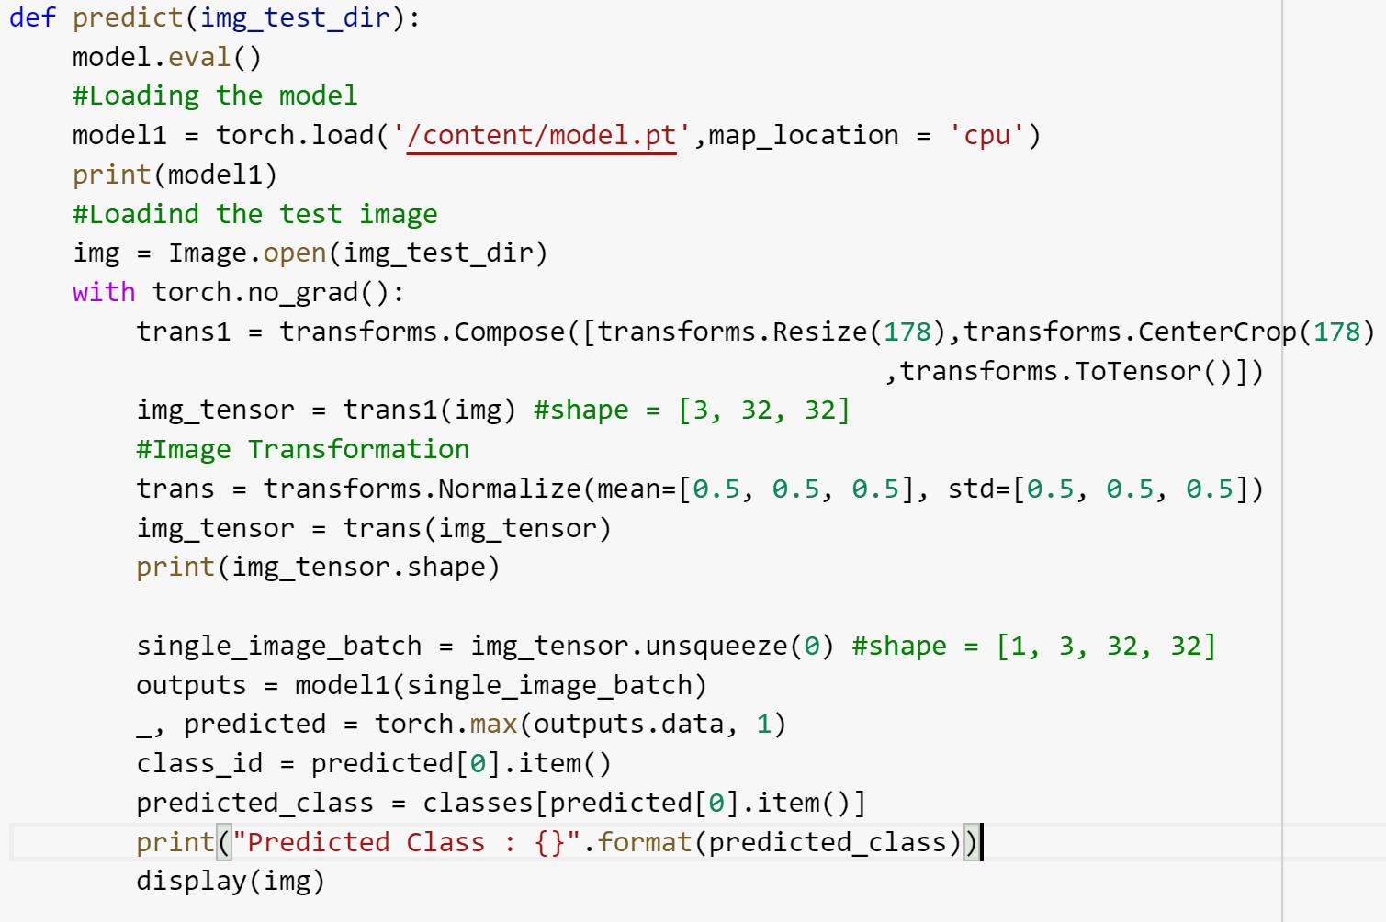

**Step 2: Hair feature Prediction Using CNN with Pytorch**

* **Exploratory Data Analysis**:

1. The attribute file had the values with -1 and 1 for the 4 hair colors which I changed to 0 and 1 for better prediction
2. The partition csv file had all the training, validation, and test data in one with values 0,1 and 2 for identification which I split into 3 different files.
3. The data was not accurate with incorrect values for hair colors as many had 0 value for all the colors, which was removed using the below code and saved into a new csv file.

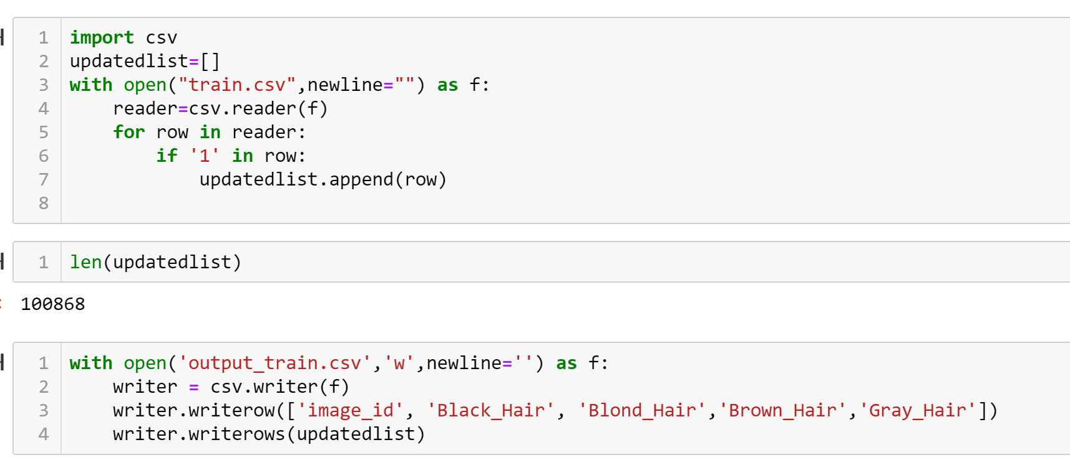

1. The 0 and 1 values of different columns were difficult to make accurate predictions, to overcome this problem a new hair color class was created.

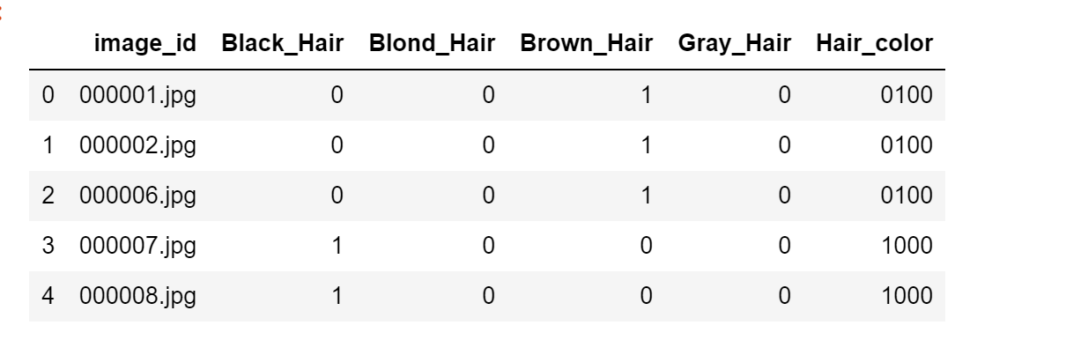

And the assigned proper numbers to the colors as 0,1,2 and 3

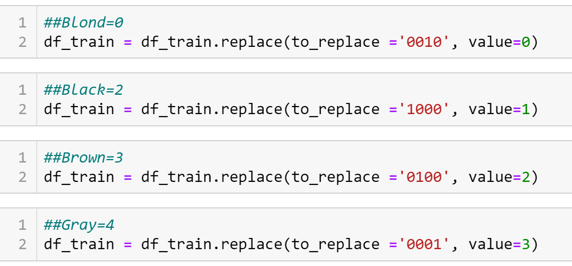

* The second part for the classification I performed hair color prediction for the celebrities with the 4 different hair colors from the data i.e. Black, Brown, Blond and Gray.

Below is the model design for Hair feature prediction

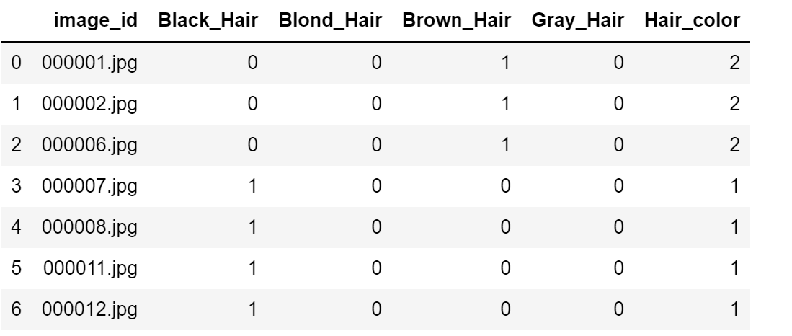

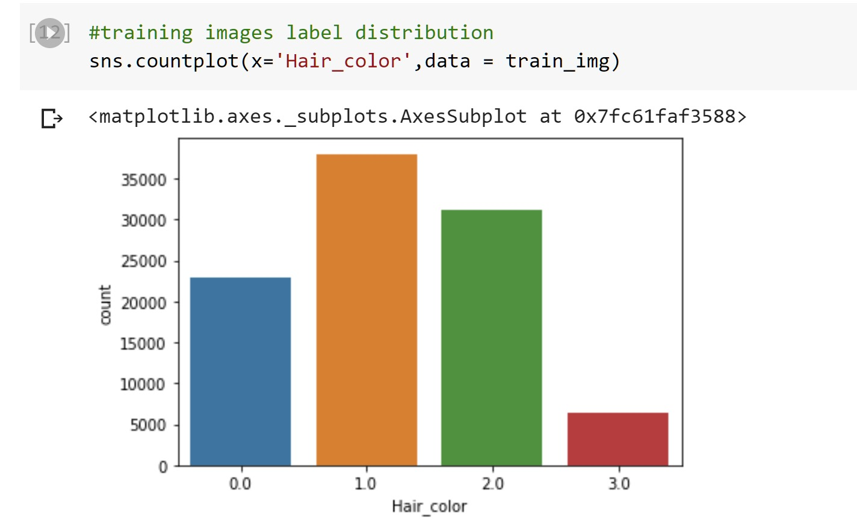

* The model learned through the train and validation data split and was able to give the correct results for the test data for the model predicting the hair color for the images with an accuracy of 93%

The train and validation images dataset were read using the below function.

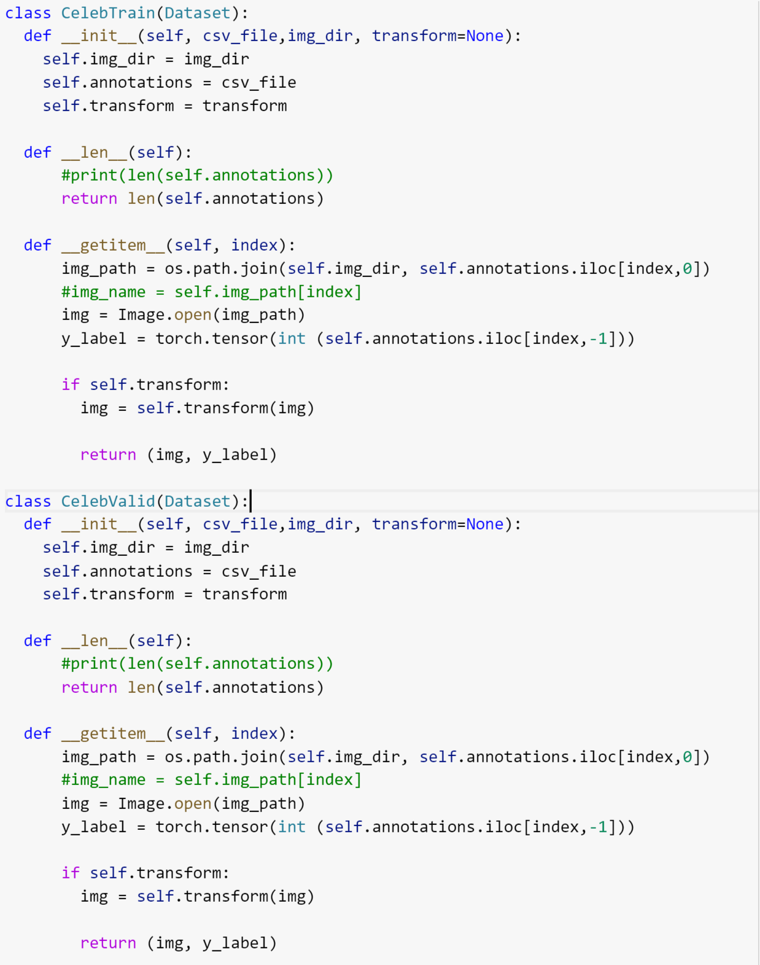

For loading the dataset, I used data loader and then transformed it to tensors with their labels 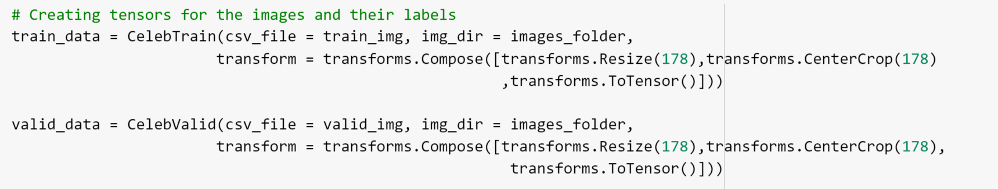

With this I resized the size of the image as it was not in proportion so to make it equal size, I transformed the image to 178 x 178

The training and the validation functions were same for both the CNN models

**Functions used in the CNN models (Gender and Hair)**

1. **Activation Function**: ReLu as this is more computationally efficient and has better convergence .
2. **Cost Function**: SGD as it is easier to fit into memory and the convergence is faster with larger datasets.
3. **Loss Function**: Cross Entropy as it is good to work with classification problems
4. **Dimensionality Reduction using MaxPool**
5. **Dropout** is good to avoid over memorization thus reducing the complexity
6. **Batch Normalization** is good to check if each node is able to learn.

**Step 3: Generating fake faces using Generative adversarial network(GAN) with Pytorch**

GAN is composed of two models:

* The first is the Generator model that has an aim to generate new data similar to the original input data. The Generator can be compared to a human art forger, who creates fake works of art. Designed the generator model to generate fake images for the dataset of celebrities

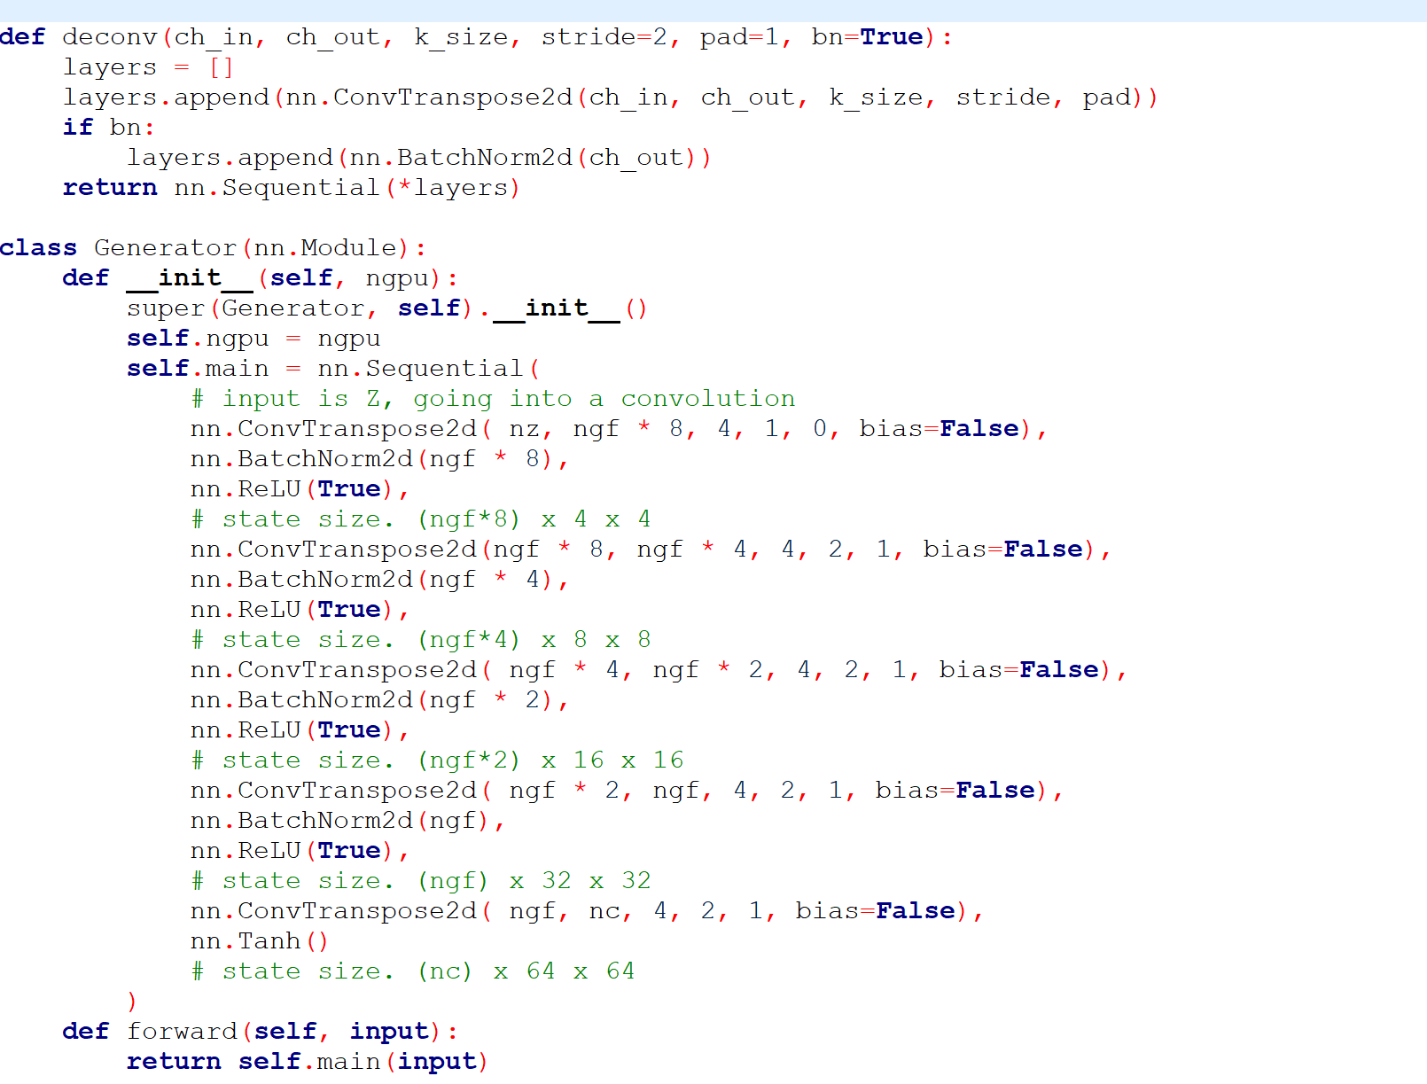

* The second is the Discriminator model whose end goal is to identify that the input data entered is original that is the same as the original dataset or if it is the fake data that the generator has created. The Discriminator is the same as one of the art experts, trying to predict the original and fake. The designed discriminator model for this project was able to predict the real and fake images separately for the celebrity images of the dataset

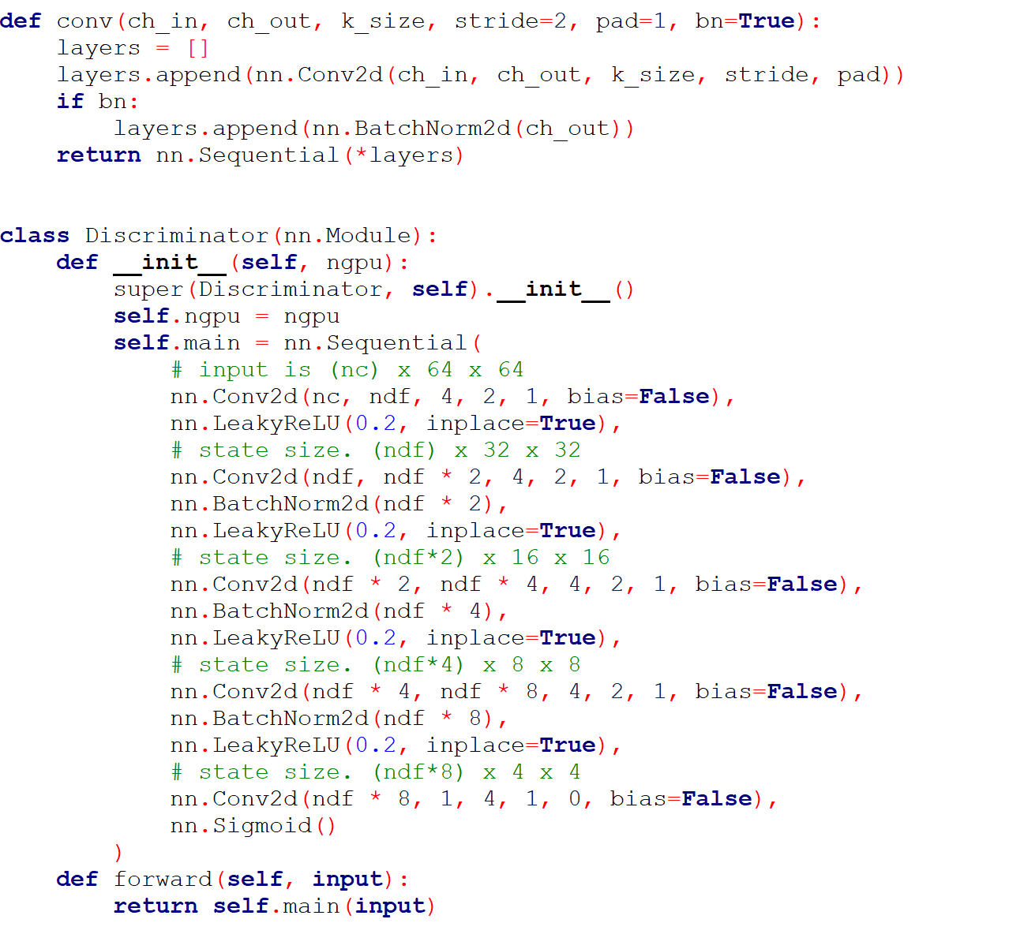

**Functions used in the GAN Model**

1. **Activation Function**: Sigmoid and ReLu as this is more computationally efficient and has better convergence.
2. **Batch Normalization** is good to check if each node can learn.
3. **Loss Function**: BCE Loss (Binary Cross Entropy) as it needs only one node to classify the data into 2 classes.

**Step 4: Parallelizing the models with multiple GPU’s using Cuda Module**

* **Parallelizing CNN gender model and hair feature model on 1,2 and 4 GPU’s**

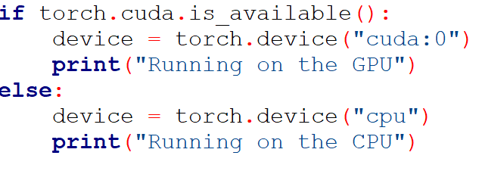

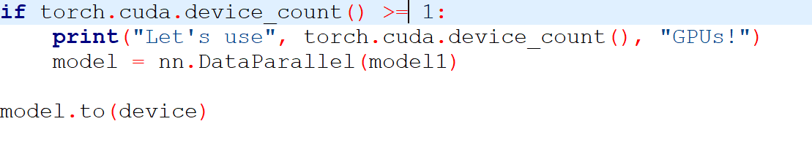

* **Parallelizing GAN on Multiple GPU’s**



**Generator**

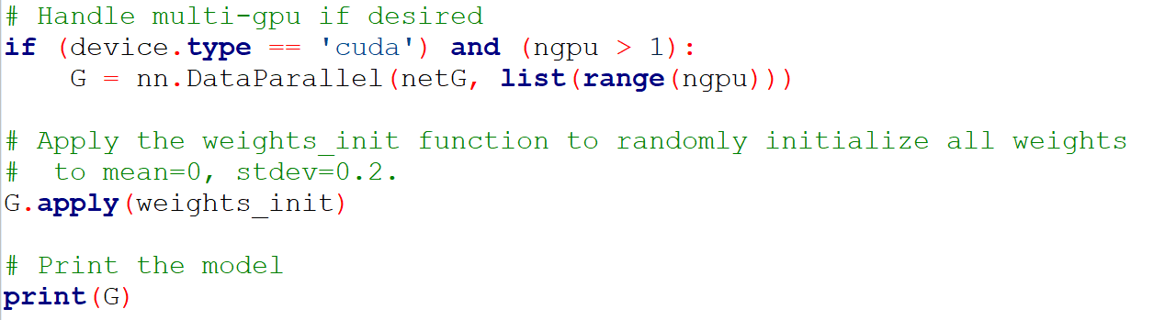

**Discriminator**

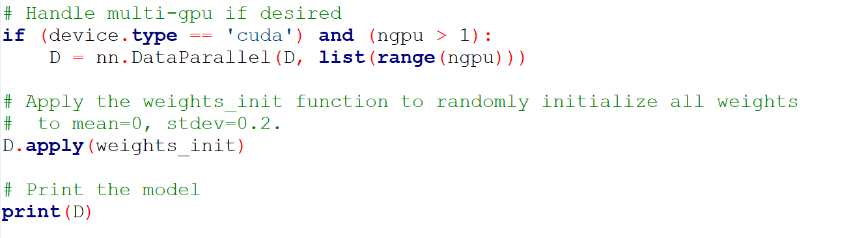

**Description of the dataset**

**Source Dataset:**

<https://www.kaggle.com/jessicali9530/celeba-dataset>

### **Dataset Description**

### **Context**

A popular component of computer vision and deep learning revolves around identifying faces for various applications from logging into your phone with your face or searching through surveillance images for a particular suspect. This dataset is great for training and testing models for face detection, particularly for recognizing facial attributes such as finding people with brown hair, are smiling, or wearing glasses.

Images cover large pose variations, background clutter, diverse people, supported by a large quantity of images and rich annotations. This data was originally collected by researchers at MMLAB, The Chinese University of Hong Kong (specific reference in Acknowledgment section).

**CelebFaces Attributes Dataset (CelebA)** is a large-scale face attributes dataset with more than **200K** celebrity images, each with **40** attribute annotations. The images in this dataset cover large pose variations and background clutter. CelebA has large diversities, large quantities, and rich annotations, including

* **10,177** number of **identities**,
* **202,599** number of **face images**, and
* **5 landmark locations**, **40 binary attributes** annotations per image.

The dataset can be employed as the training and test sets for the following computer vision tasks: face attribute recognition, face detection, landmark (or facial part) localization, and face editing & synthesis.

**Data Files**

* **img**align**celeba.zip**: All the face images, cropped and aligned
* **list**eval**partition.csv**: Recommended partitioning of images into training, validation, testing sets. Images 1-162770 are training, 162771-182637 are validation, 182638-202599 are testing
* **list**bbox**celeba.csv**: Bounding box information for each image. "x1" and "y1" represent the upper left point coordinate of bounding box. "width" and "height" represent the width and height of bounding box
* **list**landmarks**align_celeba.csv**: Image landmarks and their respective coordinates. There are 5 landmarks: left eye, right eye, nose, left mouth, right mouth
* **list**attr**celeba.csv**: Attribute labels for each image. There are 40 attributes. "1" represents positive while "-1" represents negative

Heatmap Plot for the attributes in the dataset

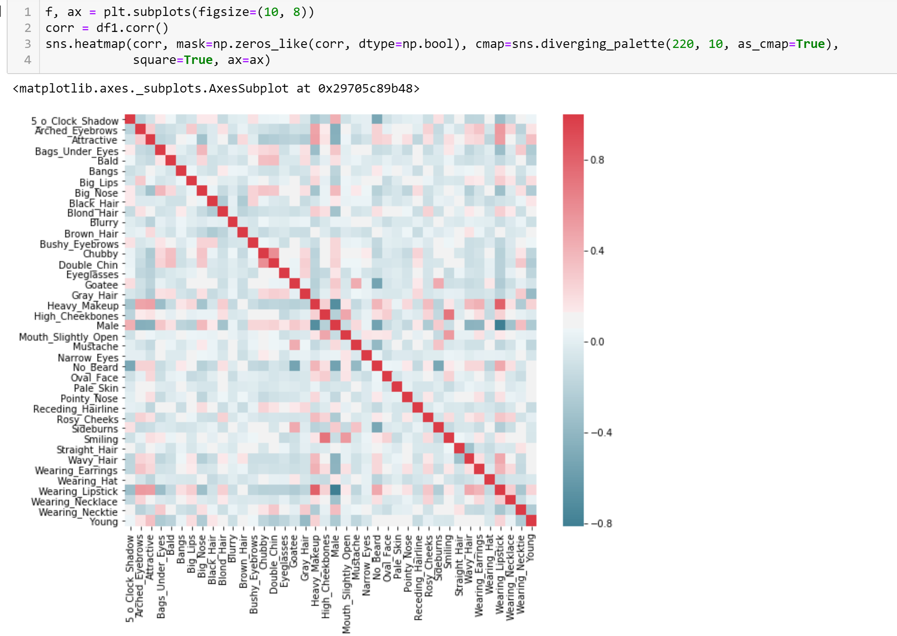

**Result and Analysis**

* **Gender Model Prediction with CNN Model execution:**

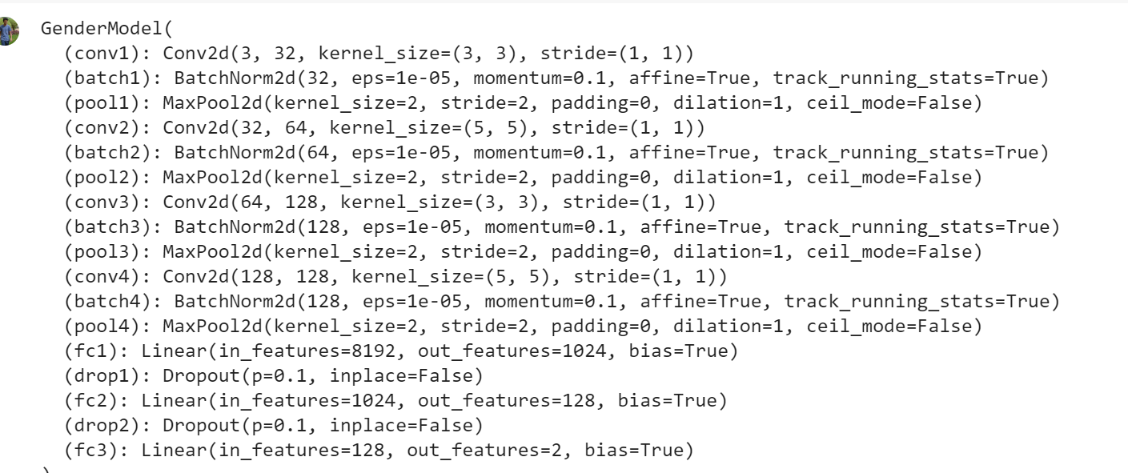

**The Plot for loss and Accuracy:**

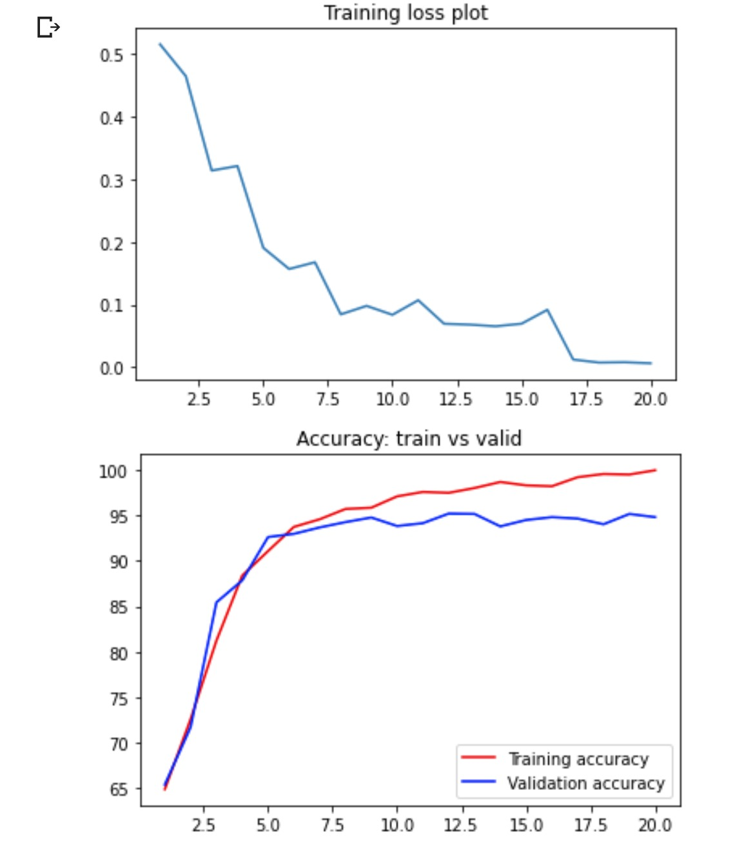

**The final outcomes from the Gender model:**

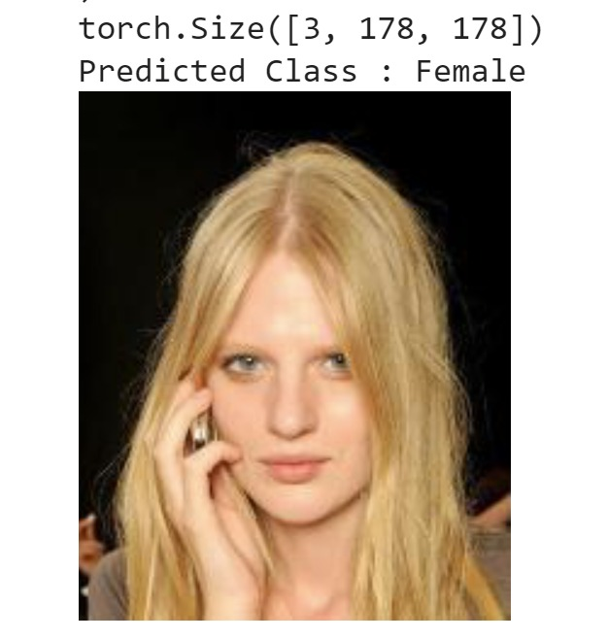 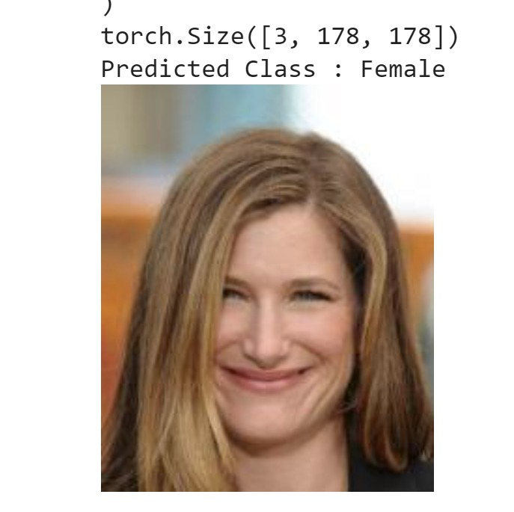

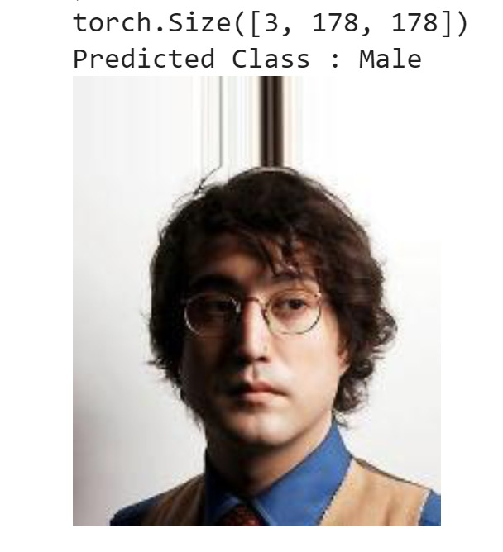 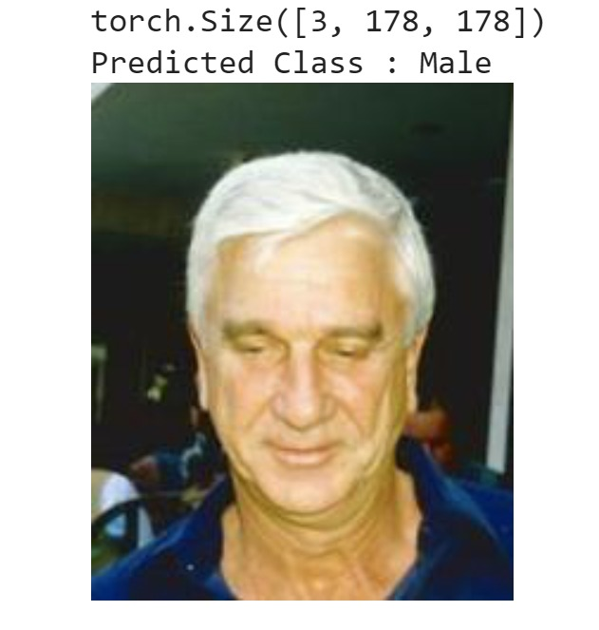

* **Hair Feature Prediction with CNN Model Execution:**

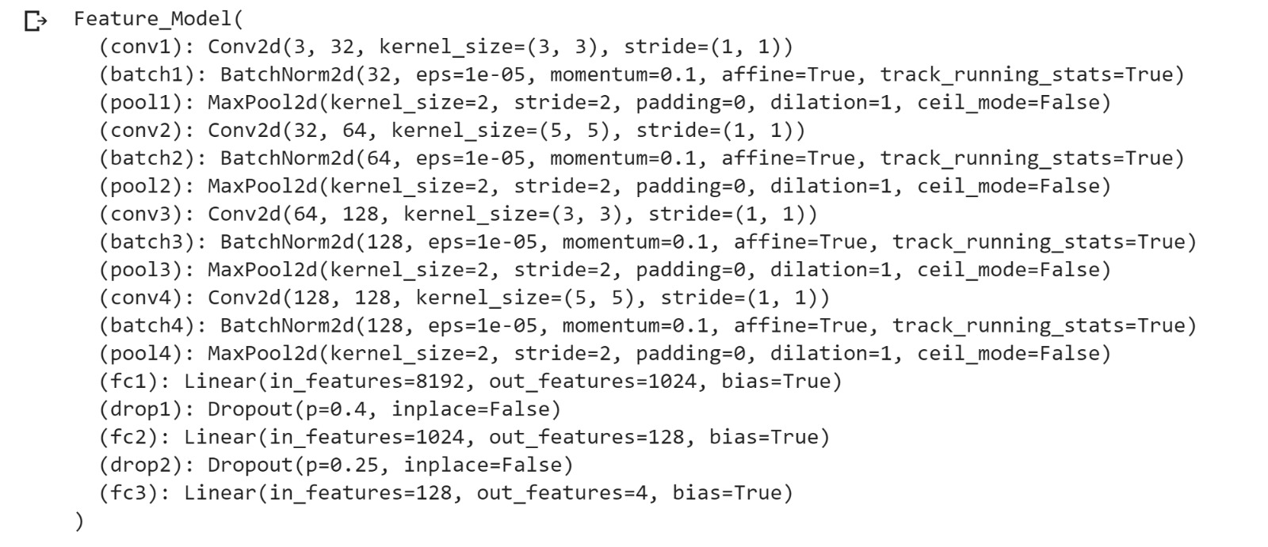

**The Plot of loss and accuracy :**

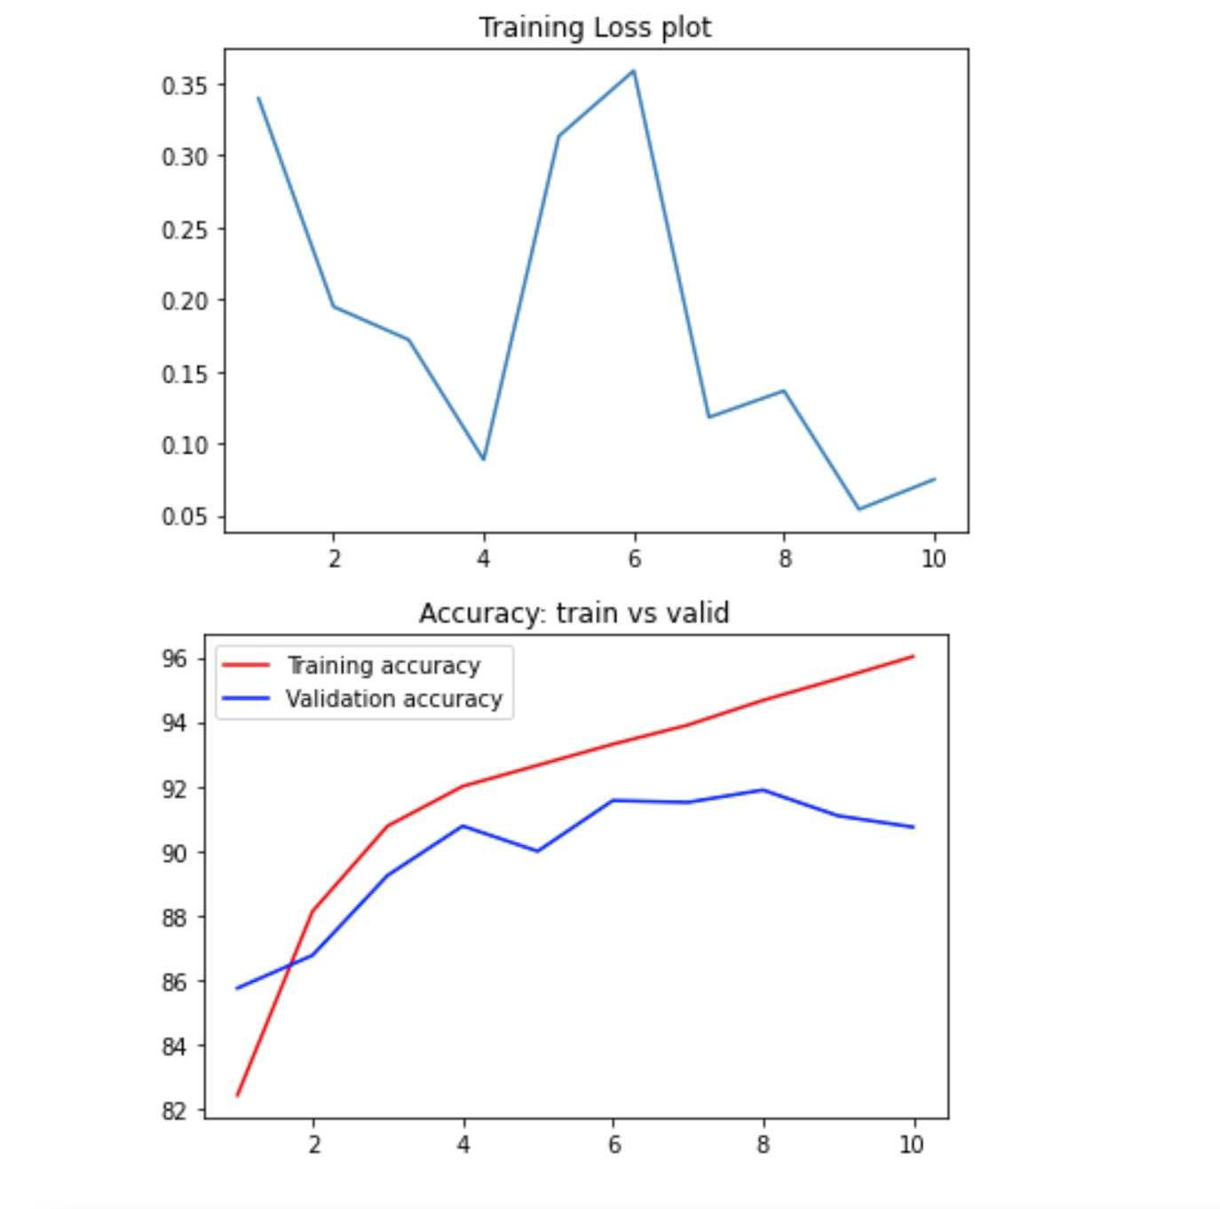

**The final outcomes from the model:**

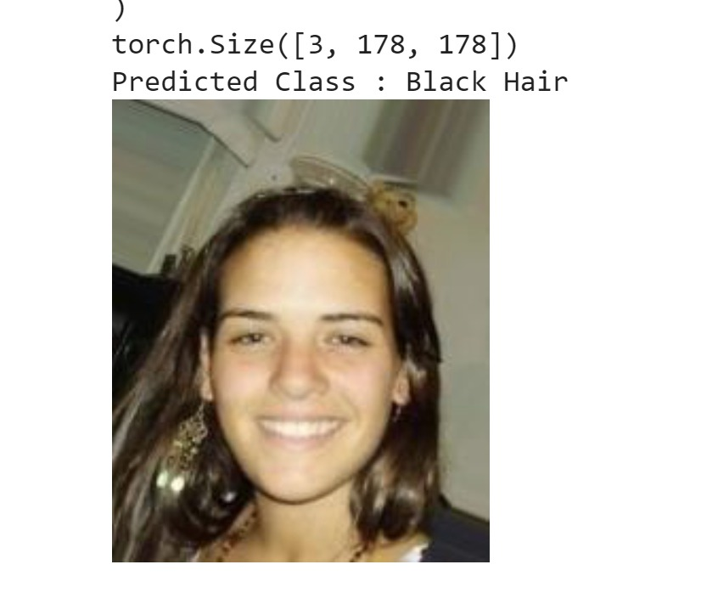 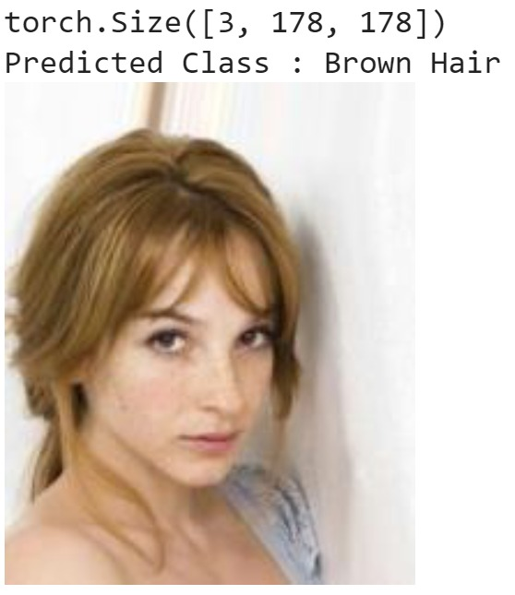

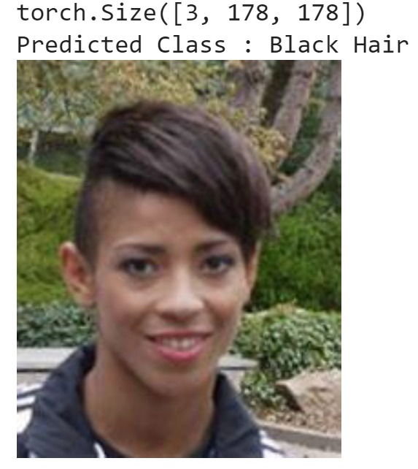 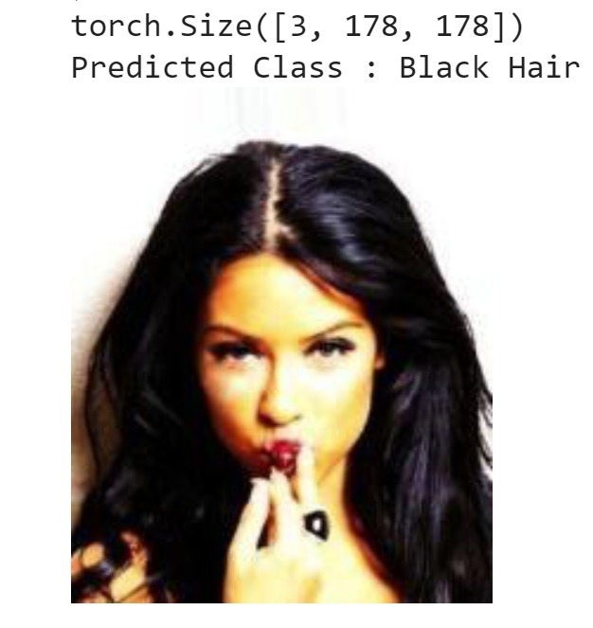

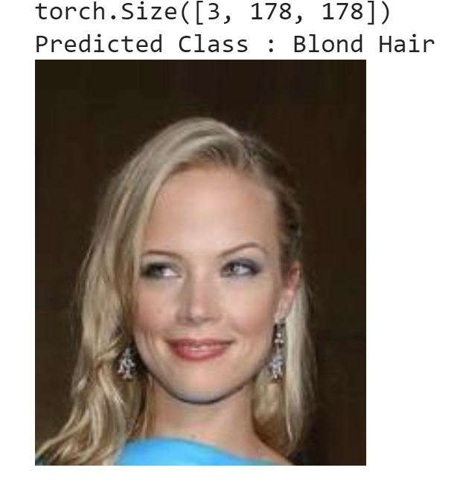 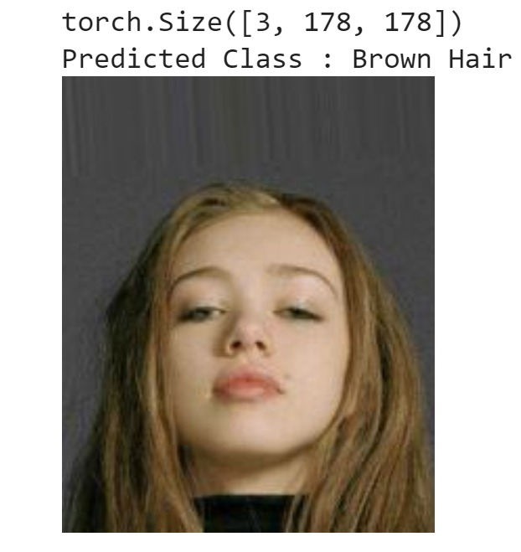

* **GAN Results Model execution:**

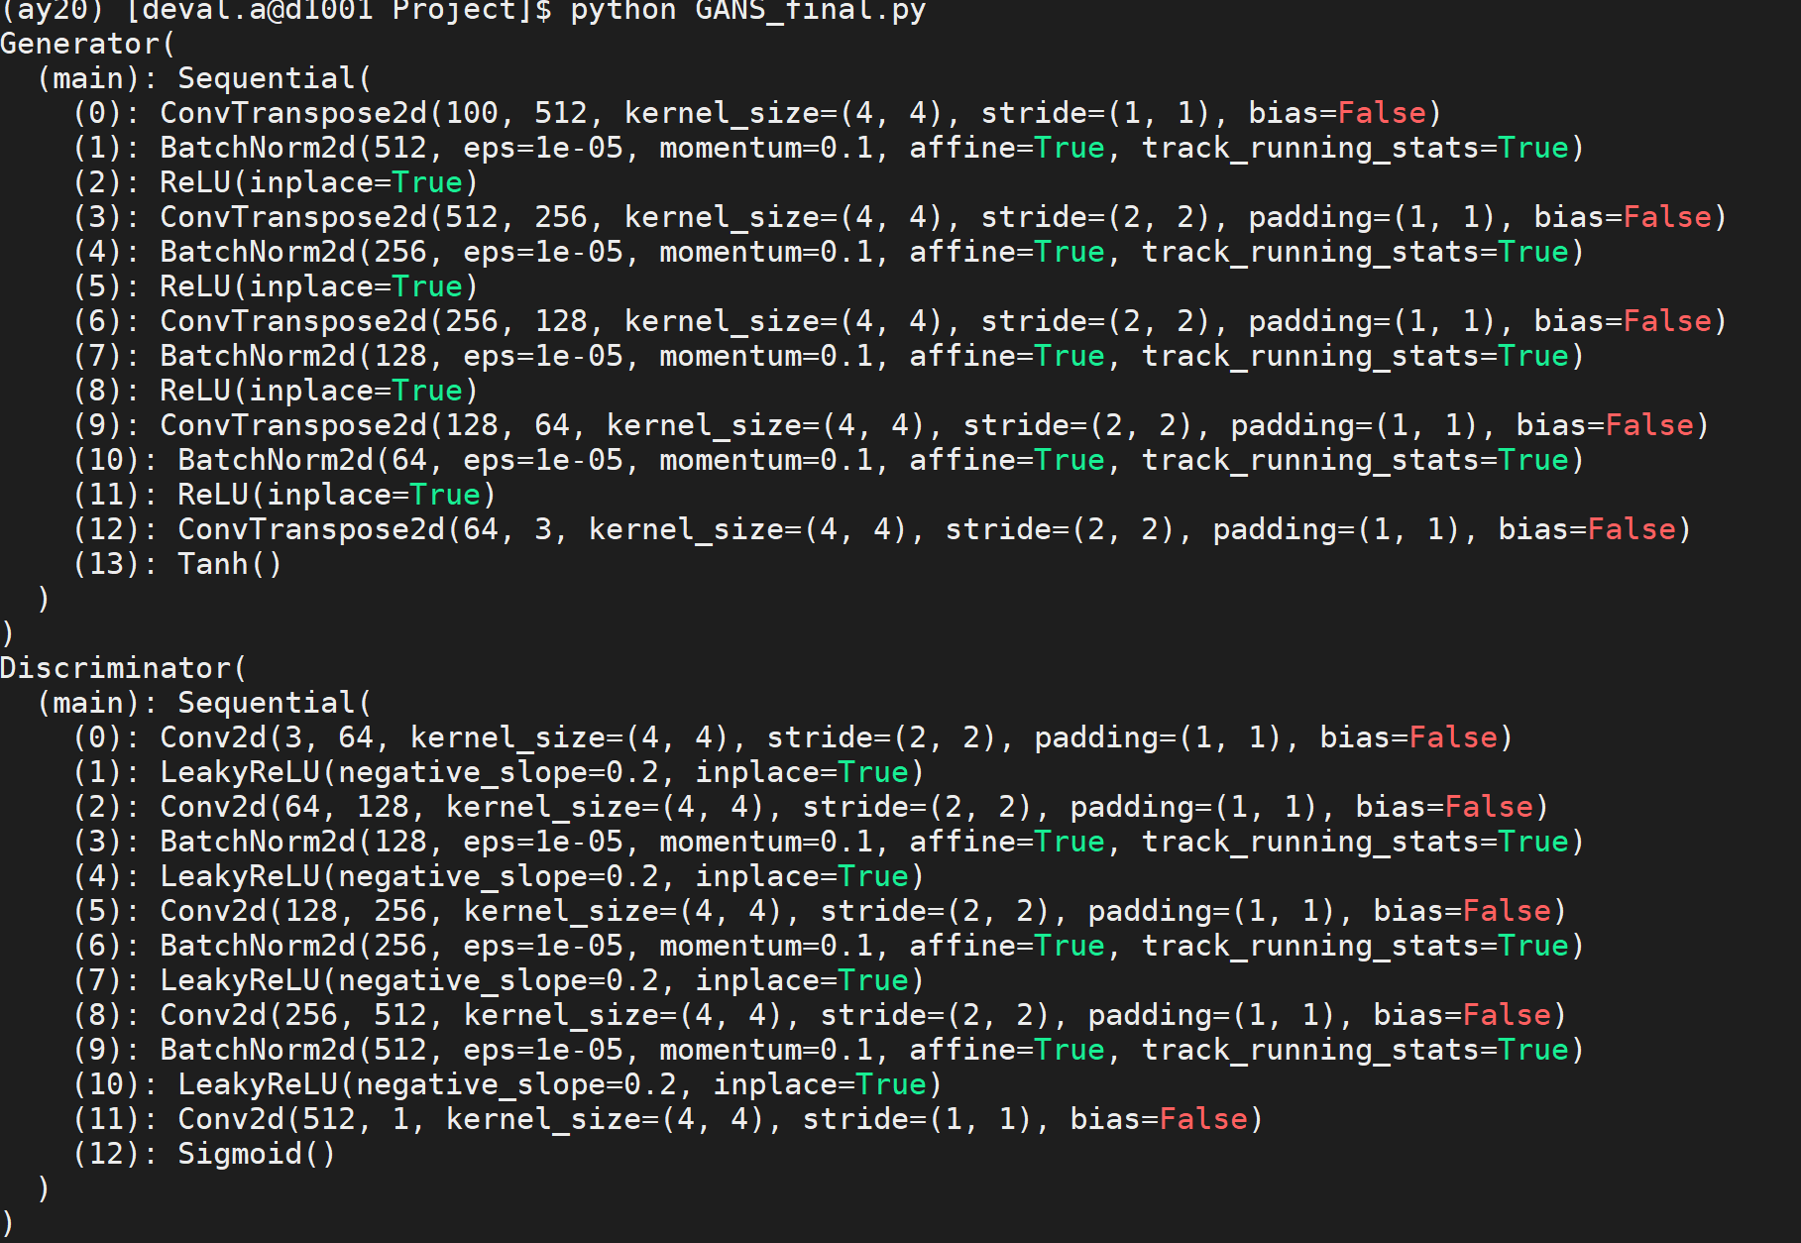

**The plot of Losses for generator and discriminator:**

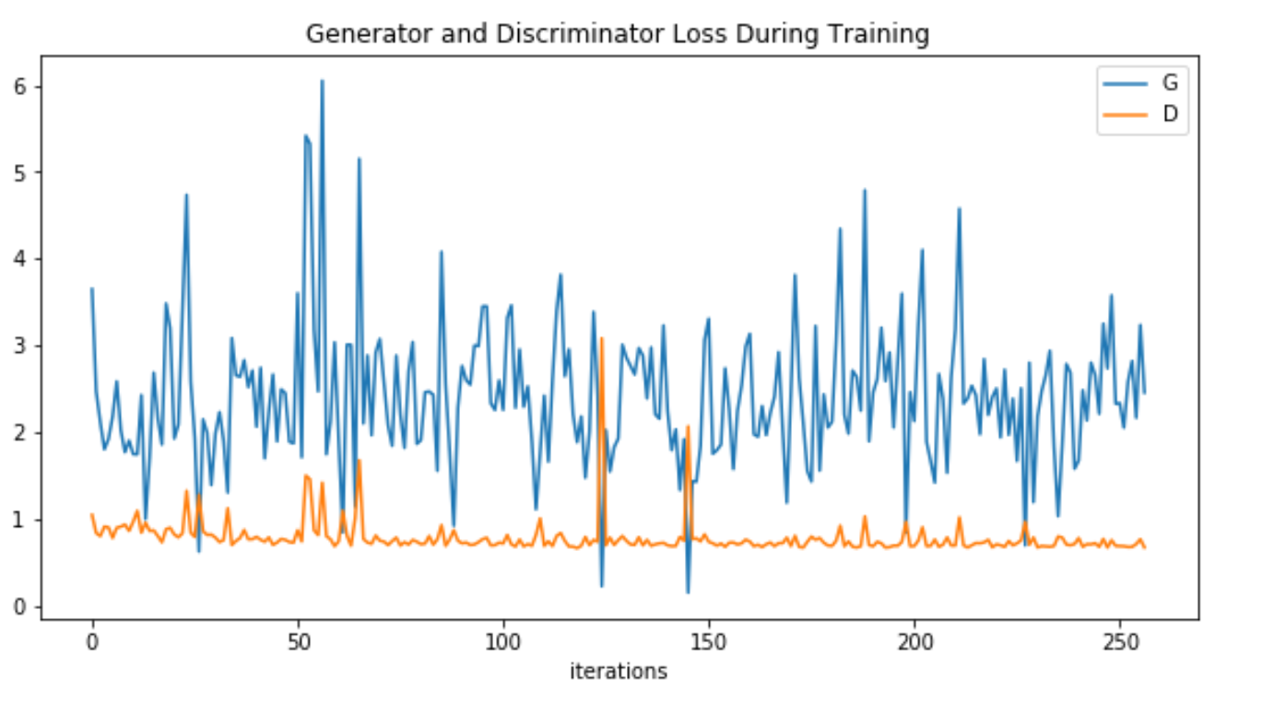

**Real Images:**

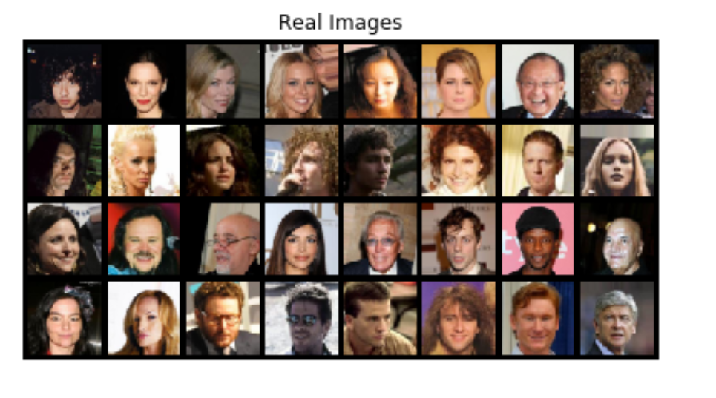

**Fake Images :**

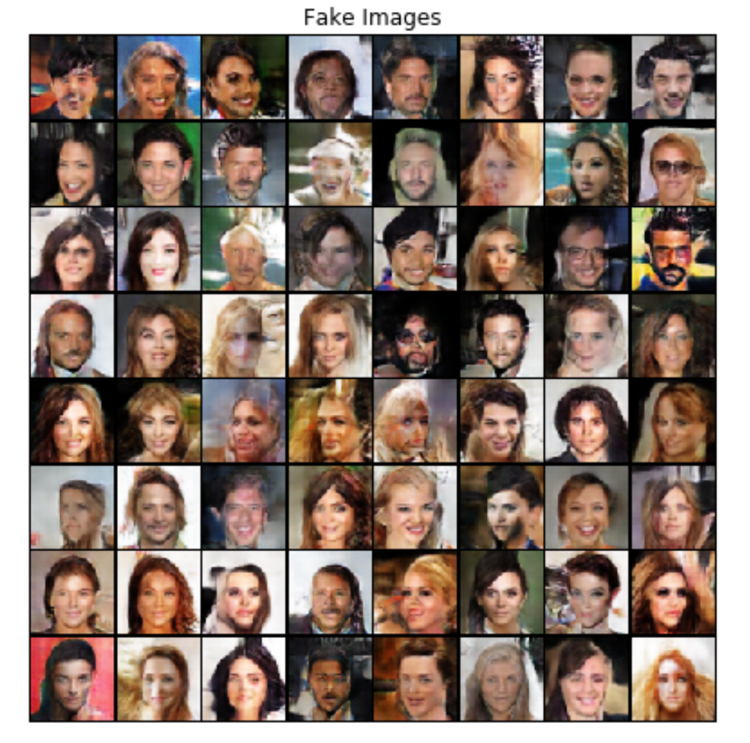

**Data Parallelism:**

The models were parallelized on Data parallelism on the cluster with multiple GPU’s.

Starting with requesting resource on the cluster and additional memory of 4GB



* **Gender Model using CNN with pytorch and parallelizing it using Cuda device on 1,2 and 4 GPU’s**

While running on 1 GPU I obtained training accuracy of 91% and validation accuracy of 92% and a total time of 92.65 seconds

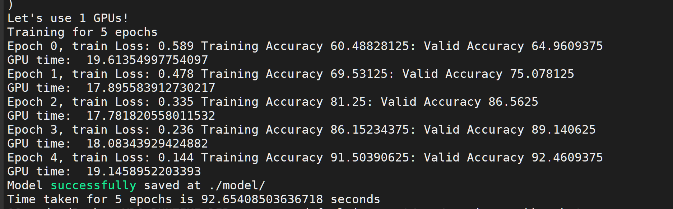

On 2 GPU’s the computing time reduced by 14 seconds and became 78.35 seconds and the training accuracy was 91% and validation accuracy came out to be 93%

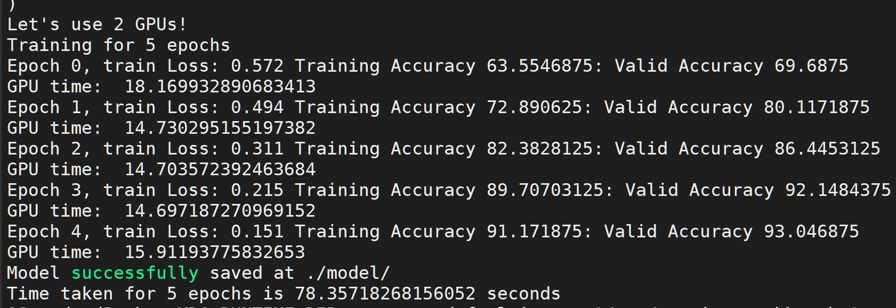

On 4 GPU’s the reduced by 6 seconds from the 2 GPU computing time, and I noted it as 72.73 seconds. The training and validation accuracies were 92%

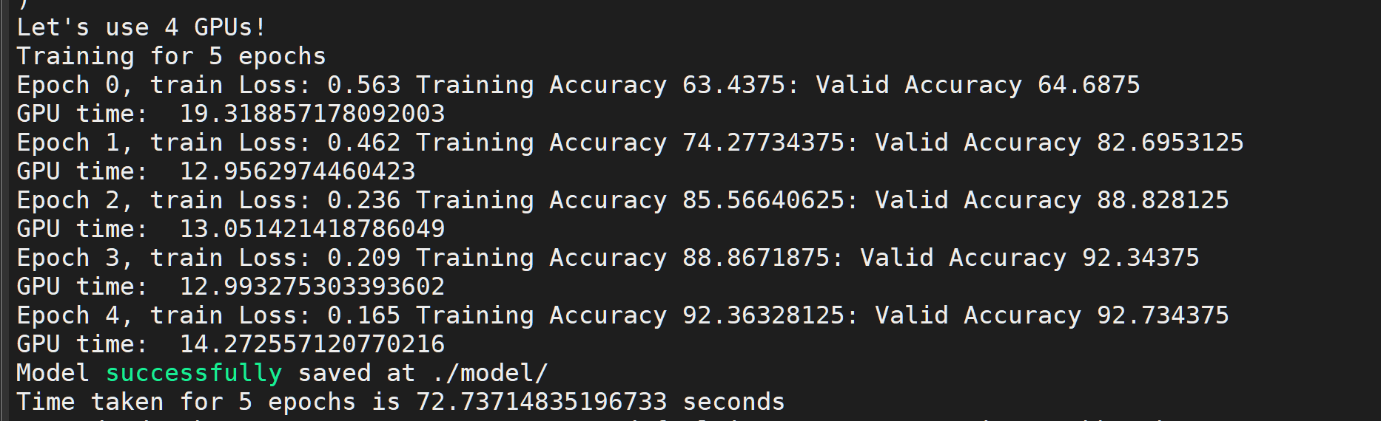

* **Hair Feature Model using CNN with pytorch and parallelizing it using Cuda device on 1,2 and 4 GPU’s**

On 1 GPU the time taken was the highest , 2331.72 seconds with the accuracies of 92% and 90% for training and validation respectively.

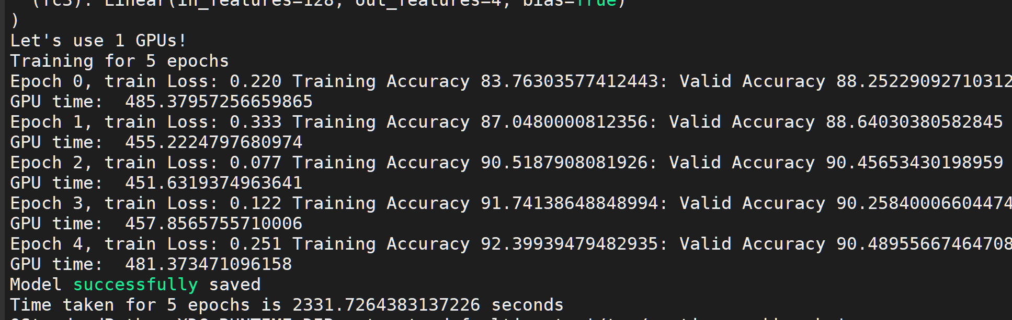

Running on 2 GPU’s I encountered the accuracies to be same as fo 1 GPU ie 92% and 90% for training and validation respectively but the total computing time reduced to 1912.40 seconds

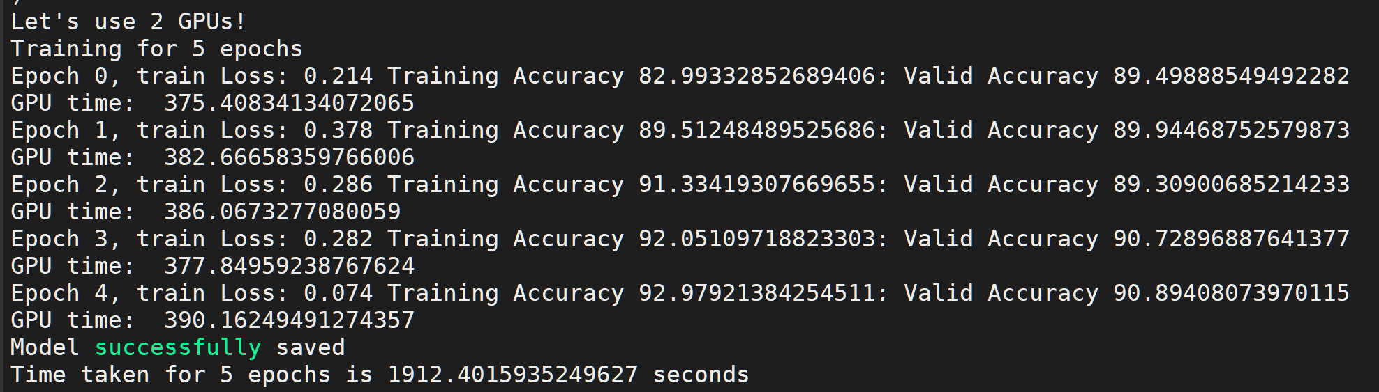

Running on 4 GPU’s the computing time was 1711.91 seconds with training accuracy as 92% and validation accuracy as 91%

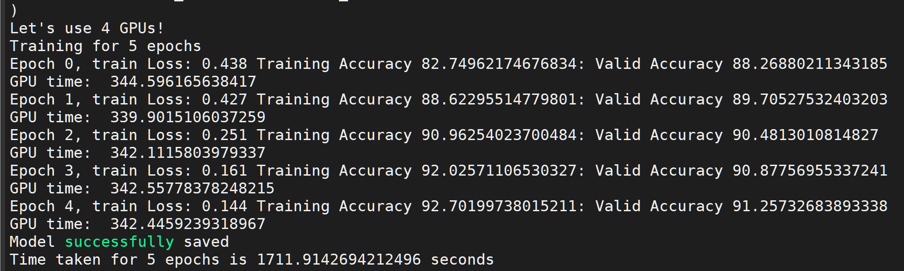

* **GAN model parallelism on cuda device on 1,2 and 4 GPU’s**

For 1 GPU the computing time of each epoch was 9500 seconds and the resultant loss function for Generator was 3.03 and Discriminator was 0.4

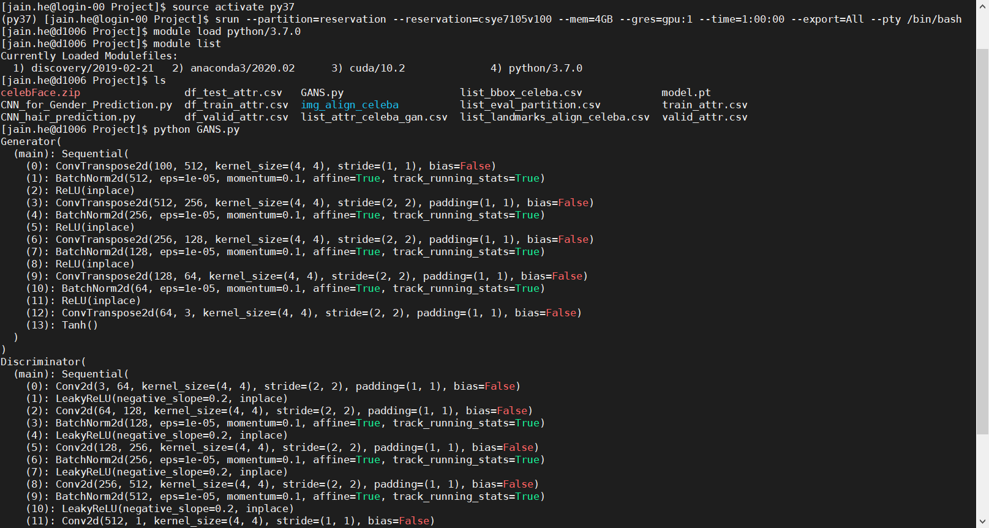

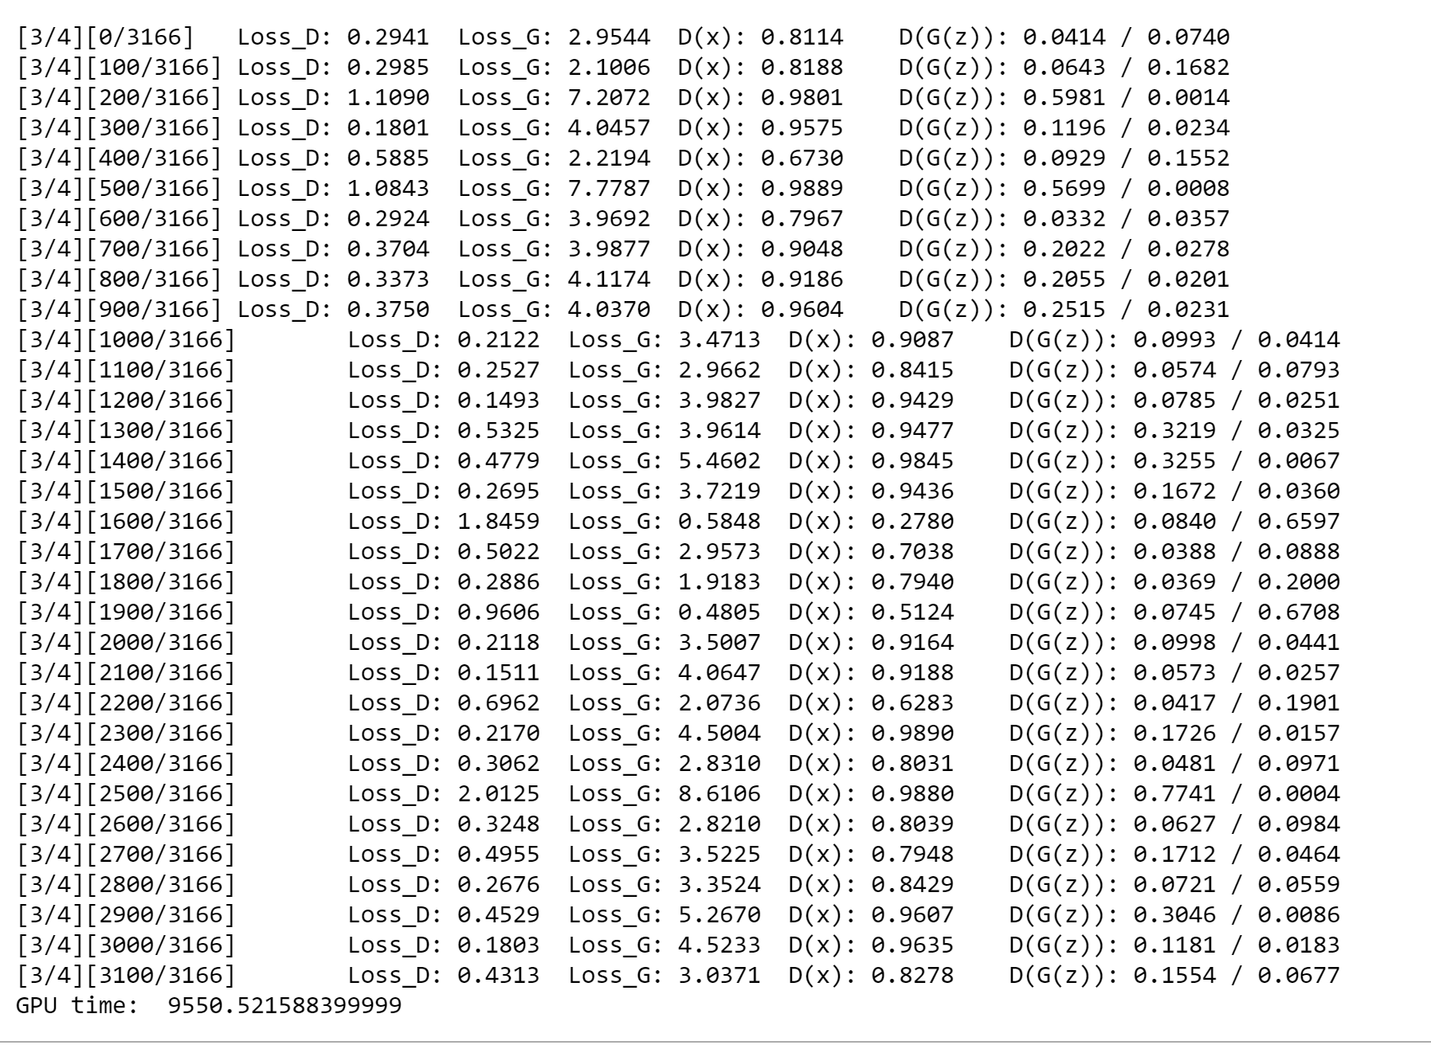

For 4 GPU’s the computing time of each epoch was 4500 seconds and the resultant loss function for Generator was 0.4 and Discriminator was 1.1

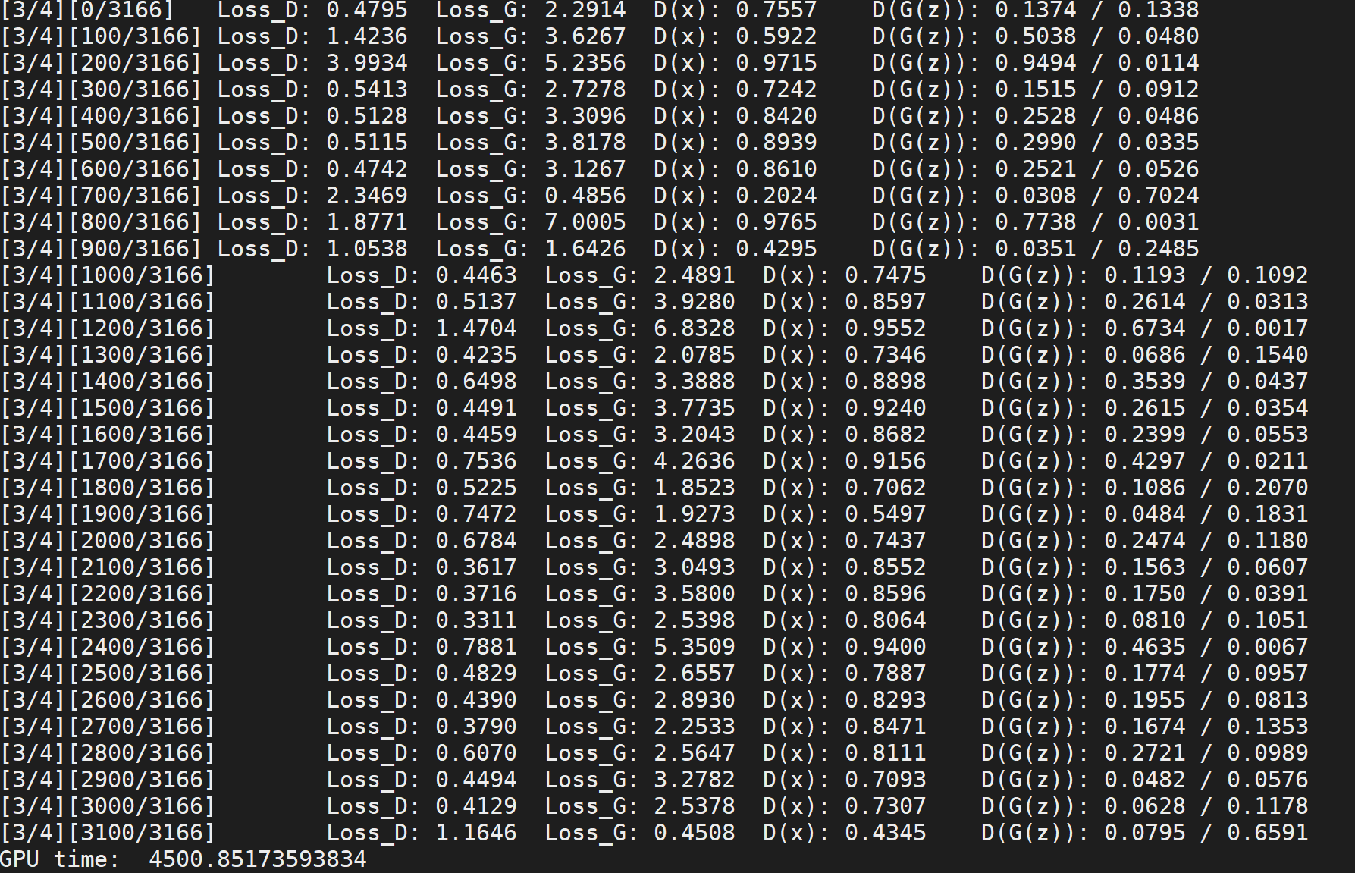

For 1 GPU the computing time for each epoch was 9550 seconds double of the 4 GPU result and the loss for Generator and Discriminator were 3.03 and 0.4, respectively.

**Streamlit based Fake Face Generation using the Nvidia trained ML model**



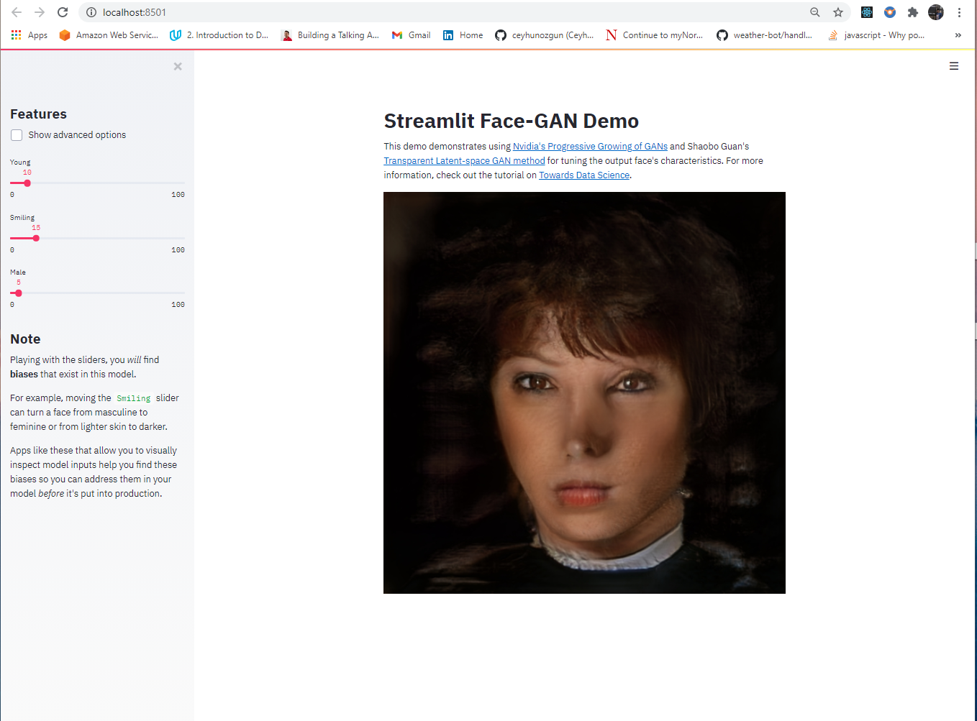

**Conclusion**

With deep learning methodologies like CNN and GANs I was able to achieve the goal I set at the starting of our project. The CNN models accurately predict the Gender and the hair colors reading through the celebrity images. With an accuracy of 92%. In the GAN model the two components i.e., the generator and the discriminator performed the task well with one generating the fake images and the other identifying between the fake and the real once. Additional Deployment of Fake Face Generative Embedded Machine Learning Model with Streamlit based App makes it quite interactive and real-time in utilizing the Pre-trained ML model from Nvidia for new face creation in no time.

**References**

1. [**https://www.kaggle.com/jessicali9530/celeba-dataset/notebooks**](https://www.kaggle.com/jessicali9530/celeba-dataset/notebooks)
2. [**https://stackoverflow.com/questions/43288550/iopub-data-rate-exceeded-in-jupyter-notebook-when-viewing-image**](https://stackoverflow.com/questions/43288550/iopub-data-rate-exceeded-in-jupyter-notebook-when-viewing-image)
3. [**https://pytorch.org/tutorials/beginner/blitz/data_parallel_tutorial.html**](https://pytorch.org/tutorials/beginner/blitz/data_parallel_tutorial.html)
4. [**https://analyticsindiamag.com/multi-label-image-classification-with-tensorflow-keras/**](https://analyticsindiamag.com/multi-label-image-classification-with-tensorflow-keras/)
5. [**https://www.kaggle.com/waltermaffy/create-fake-face-with-pytorch**](https://www.kaggle.com/waltermaffy/create-fake-face-with-pytorch)
6. [**https://stackoverflow.com/questions/45303186/delete-row-from-file-using-csv-reader-and-lists-python**](https://stackoverflow.com/questions/45303186/delete-row-from-file-using-csv-reader-and-lists-python)
7. [**https://stackoverflow.com/questions/44613507/typeerror-join-argument-must-be-str-or-bytes-not-nonetype**](https://stackoverflow.com/questions/44613507/typeerror-join-argument-must-be-str-or-bytes-not-nonetype)
8. [**https://www.kaggle.com/c/jigsaw-unintended-bias-in-toxicity-classification/discussion/91081**](https://www.kaggle.com/c/jigsaw-unintended-bias-in-toxicity-classification/discussion/91081)
9. [**https://pytorch.org/tutorials/beginner/dcgan_faces_tutorial.html**](https://pytorch.org/tutorials/beginner/dcgan_faces_tutorial.html)
10. [**https://medium.com/ai-society/gans-from-scratch-1-a-deep-introduction-with-code-in-pytorch-and-tensorflow-cb03cdcdba0f**](https://medium.com/ai-society/gans-from-scratch-1-a-deep-introduction-with-code-in-pytorch-and-tensorflow-cb03cdcdba0f)
11. [**https://rc-docs.northeastern.edu/en/latest/software/software.html**](https://rc-docs.northeastern.edu/en/latest/software/software.html)
12. [**https://rc-docs.northeastern.edu/en/latest/using-discovery/transferringdata.html**](https://rc-docs.northeastern.edu/en/latest/using-discovery/transferringdata.html)
13. [**https://pytorch.org/tutorials/**](https://pytorch.org/tutorials/)
14. [**https://stackoverflow.com/questions/55274469/slurm-python-multiprocessing-exceed-memory-limit**](https://stackoverflow.com/questions/55274469/slurm-python-multiprocessing-exceed-memory-limit)
15. [**https://forum.qt.io/topic/108466/installation-error-qstandardpaths-xdg_runtime_dir-not-set-defaulting-to-tmp-runtime-root/4**](https://forum.qt.io/topic/108466/installation-error-qstandardpaths-xdg_runtime_dir-not-set-defaulting-to-tmp-runtime-root/4)
16. [**https://towardsdatascience.com/how-to-train-an-image-classifier-in-pytorch-and-use-it-to-perform-basic-inference-on-single-images-99465a1e9bf5**](https://towardsdatascience.com/how-to-train-an-image-classifier-in-pytorch-and-use-it-to-perform-basic-inference-on-single-images-99465a1e9bf5)
17. [**https://towardsdatascience.com/understanding-cnn-convolutional-neural-network-69fd626ee7d4**](https://towardsdatascience.com/understanding-cnn-convolutional-neural-network-69fd626ee7d4)
18. S. Yang, P. Luo, C. C. Loy, and X. Tang, "From Facial Parts Responses to Face Detection: A Deep Learning Approach", in IEEE International Conference on Computer Vision (ICCV), 2015
19. [**https://arxiv.org/pdf/1909.11573.pdf**](https://arxiv.org/pdf/1909.11573.pdf)
20. [**https://www.researchgate.net/publication/334811480_Culturally_Evolved_GANs_for_Generating_Fake_Stroke_Faces**](https://www.researchgate.net/publication/334811480_Culturally_Evolved_GANs_for_Generating_Fake_Stroke_Faces)